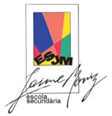
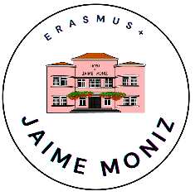
ESCOLA SECUNDÁRIA
JAIME MONIZ

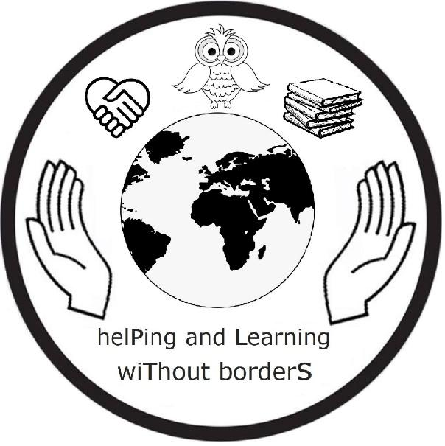
Erasmus+ Project 2020-1-PL01-KA229-082145
C1 – INDEPENDENT ENQUIRERS
FUNCHAL, MADEIRA - 06.03.2023 - 10.03.2023

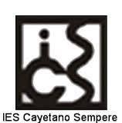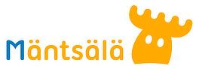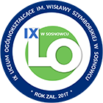
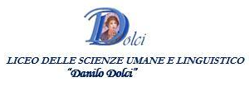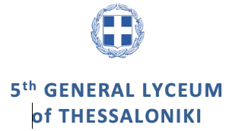

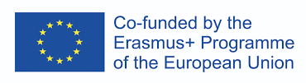
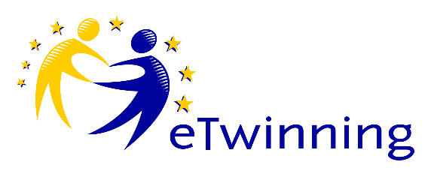

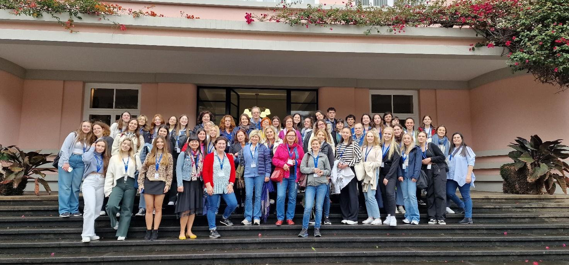
Day 1
International teams of participants researched what it means to be an independent explorer, what are the principles and typical expressions to support learning in this area. Students in mixed teams discussed and wrote down what it means in practice and how to become an independent explorer in the areas of emotion, time, energy and space. Together they came up with two digital posters that will be translated and shared in their native language with the school community about what they have learned. They participated in a practical workshop on being an independent questioner, where they were asked to analyse a situation and provide an independently and critically considered solution to the problems presented.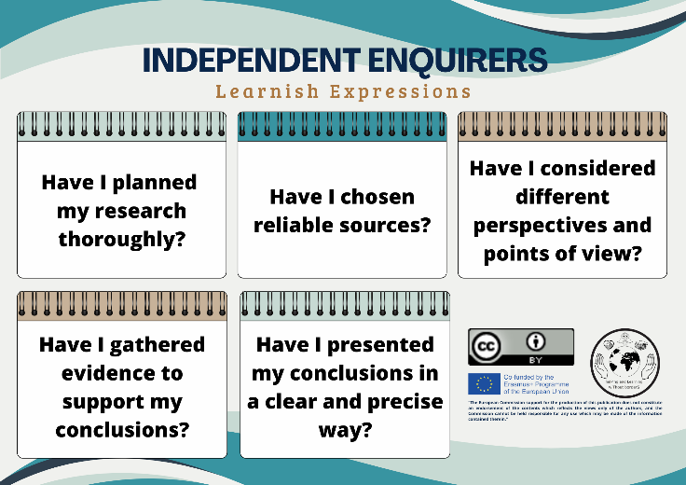 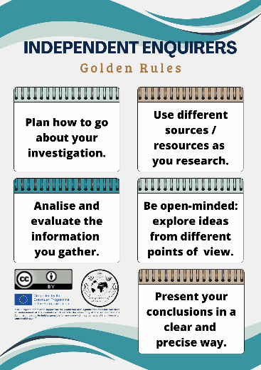
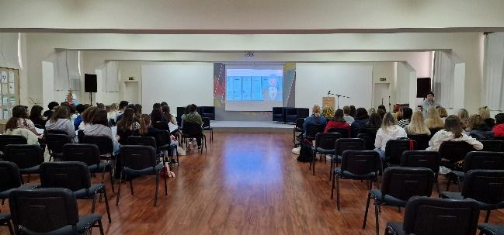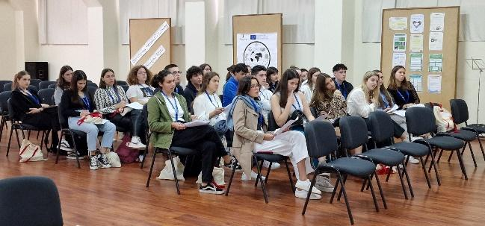

In order to learn about the culture of the region, the students were invited on a tour of the host school and the city of Funchal. They were asked to work in groups to solve puzzles and decipher clues that allowed them to find out the importance of the place they visited to the local community and where they should go next. So, as well as exploring the area, the students were also encouraged to work together to get the best out of their efforts, in a fun and enjoyable way. 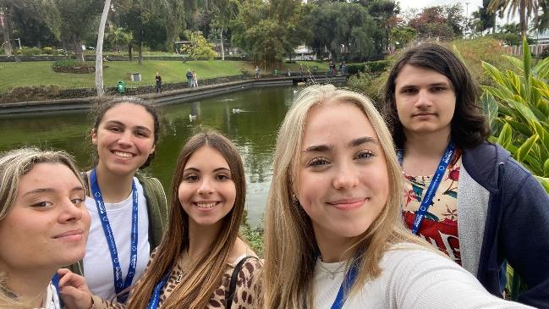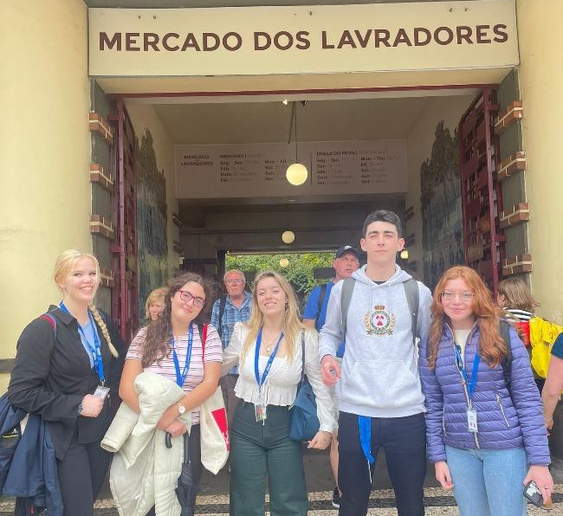
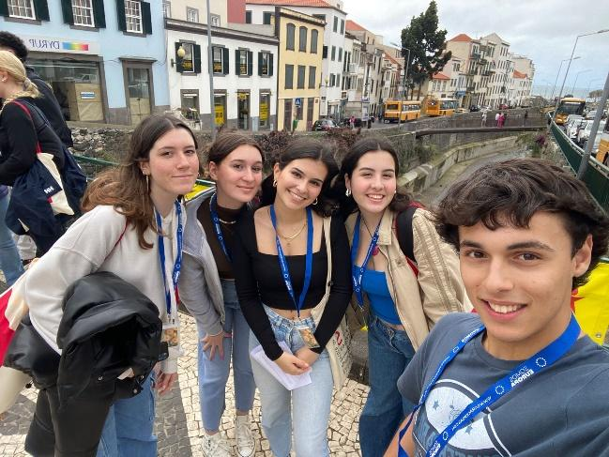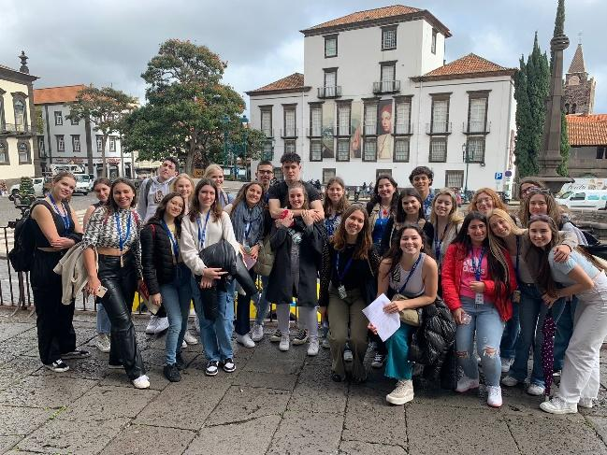

conXego's volunteer association, Naninhas do Bem Madeira, was invited to share what they do for the community, and students took the opportunity to support their cause with donations.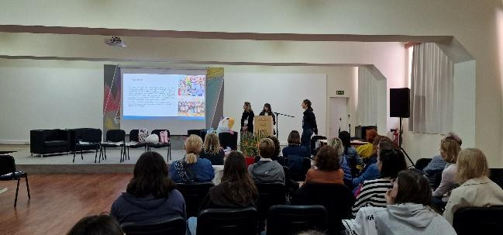 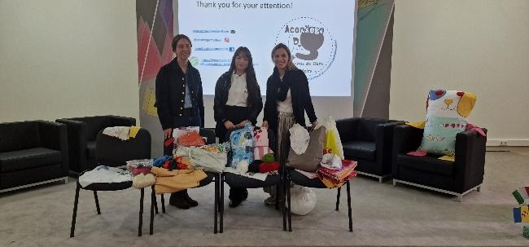
Days 2 - 3 - 4
Students were asked to work in international teams on the theme 'Human need for water', which was about water and the human body, the state of fresh water in the world, water consumption and the Earth's water resources. The participants watched a film on "Are we running out of clean water?", by Balsher Singh Sidhu, and completed a Kahoot questionnaire on it. After researching the status of water consumption in each partner's areas, the students created a PowerPoint presentation on 'Water Management - A Comparative Study', which was presented by spokespersons from all countries.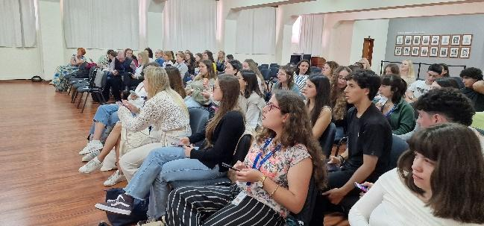 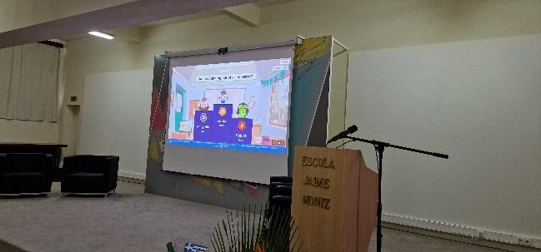
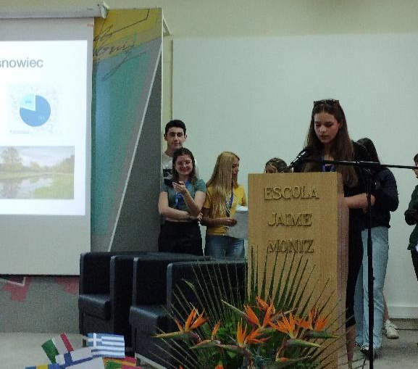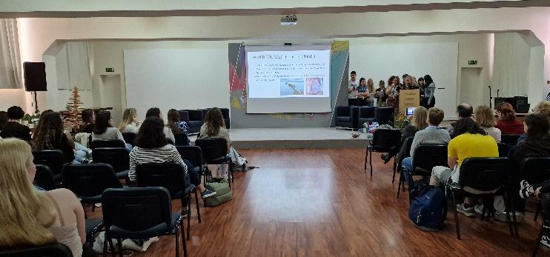
The group of students and teachers visited a hydroelectric power station, a water treatment plant and participated in a class taught by vocational school students on several techniques for treating water to make it ready for consumption. The group also had the opportunity to visit one of several rainwater reservoirs spread throughout the island, which provide water for hydroelectric power plants and agricultural irrigation, and to walk along one of the many levadas, a network of water canals that have been built on the island and which allow water to be transported from the mountains down to the coastal areas where it is most needed for crops and cattle. These water channels are likely to be listed as a Unesco World Heritage Site. Each team was then expected to record a social commercial to raise awareness about the scarcity of drinking water worldwide.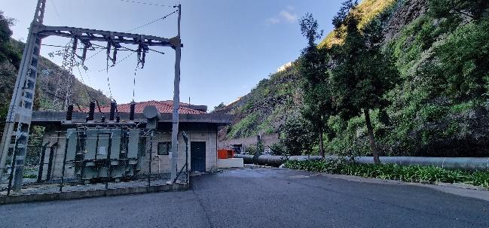
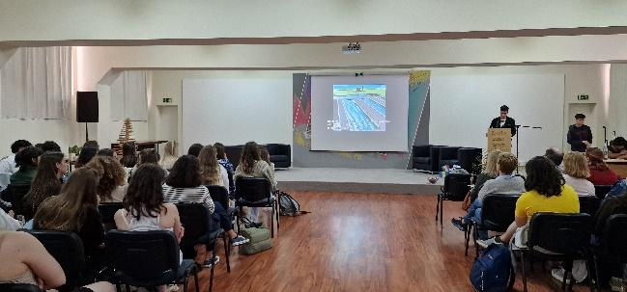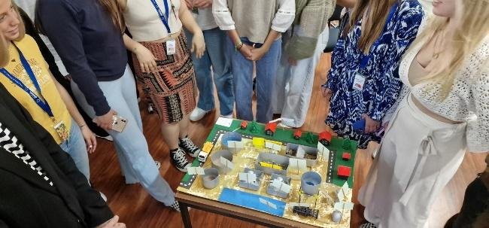
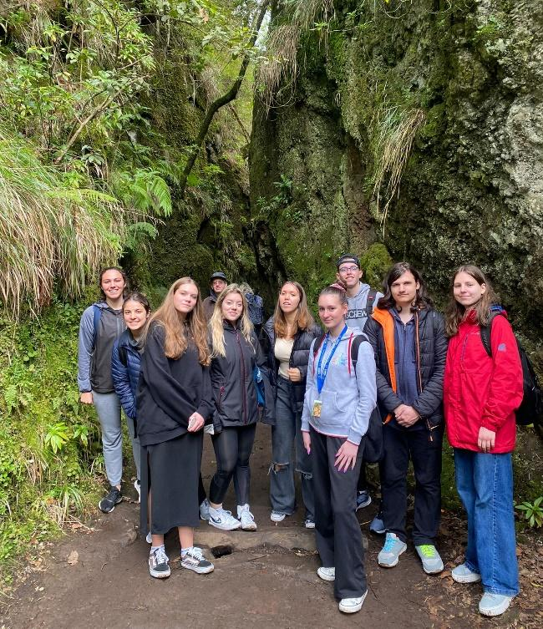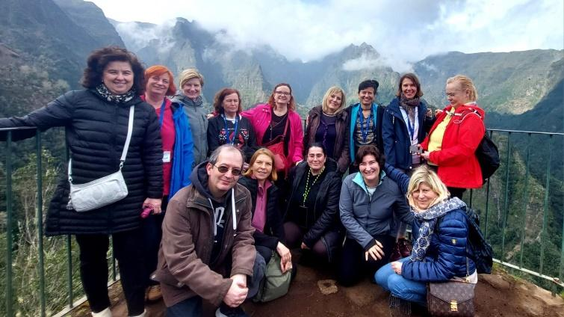
Day 5
The week ended with the presentation of the videos each group had created describing the activities they had participated in during the week, the presentation of certificates, the completion of questionnaires about their journey towards becoming more informed, independent questioners and their week-long experience in Madeira.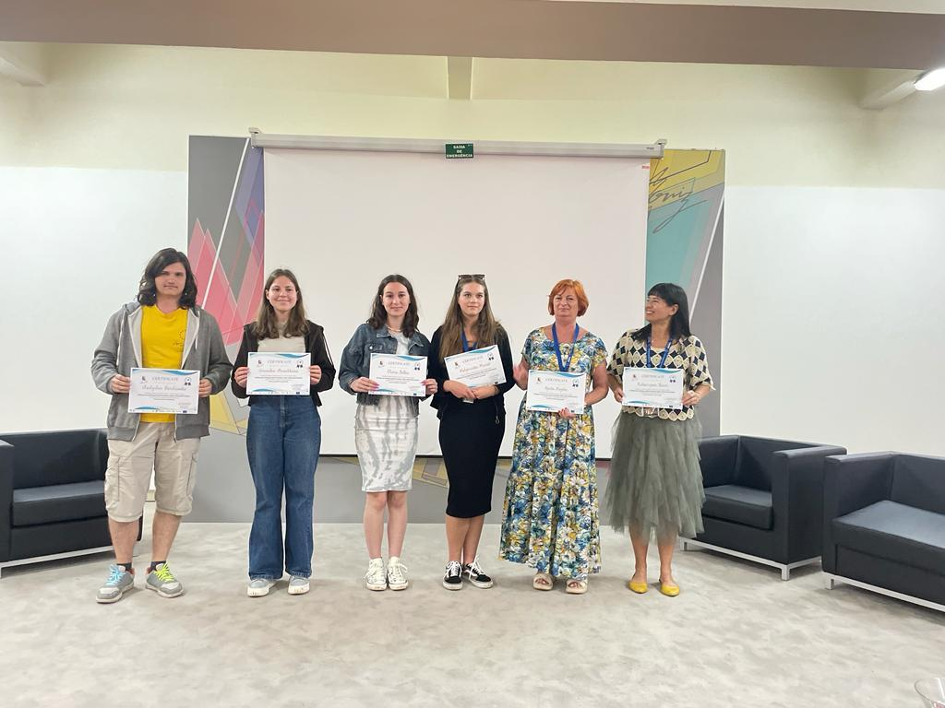
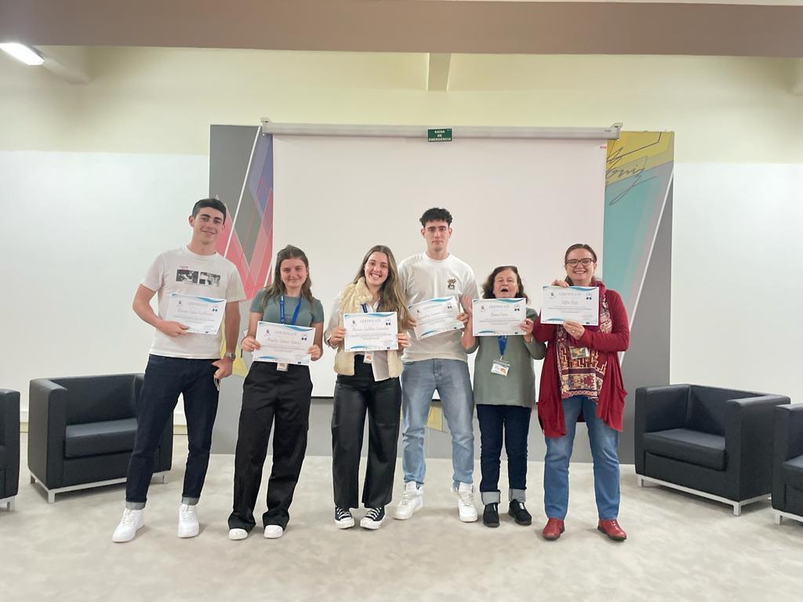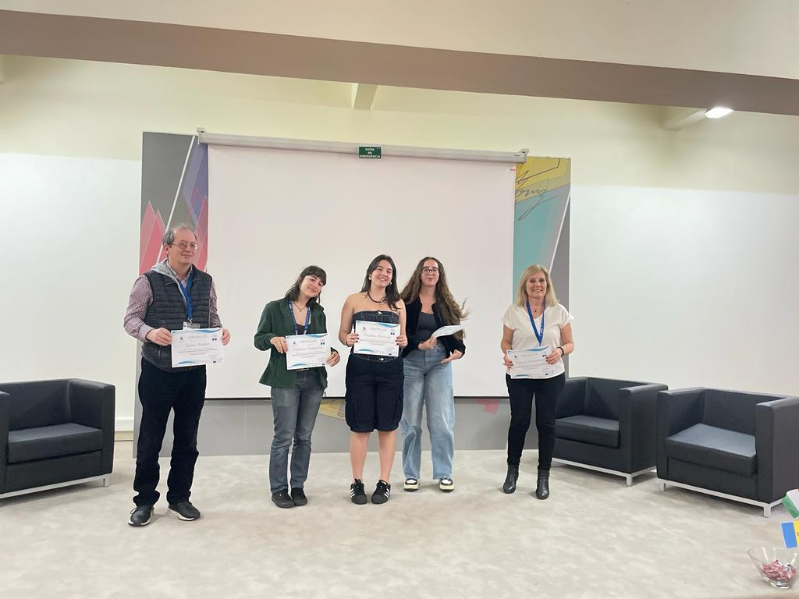
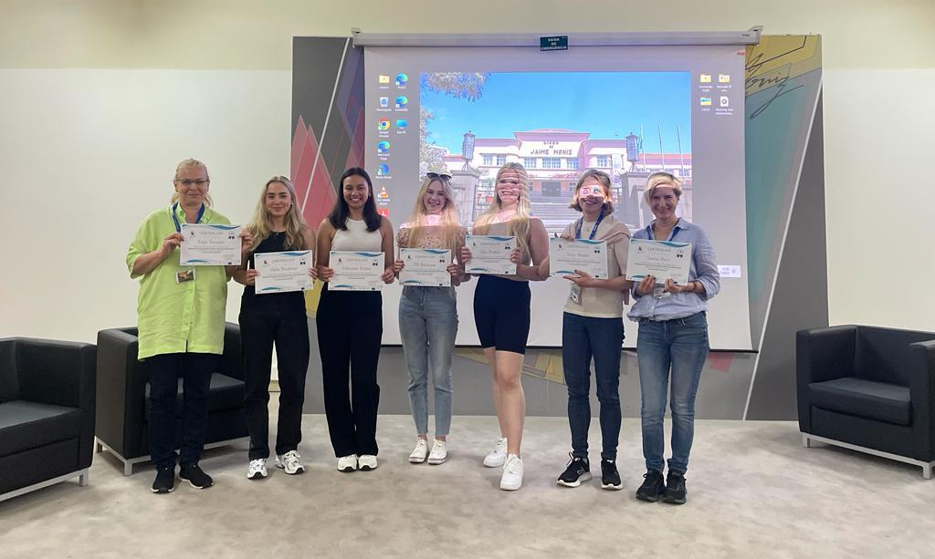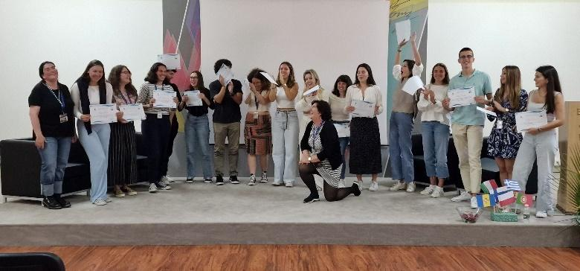

LEARNING2LEARN BENEFITS:
The activities carried out during this mobility enabled the students to learn what it means to be an Independent Inquirer and why it is important; to develop skills such as getting involved, persuading others, identifying problems and finding solutions. They also learned that their active participation can make a significant difference to the local community. Other benefits include: the opportunity for movement and face-to-face conversation; improving real-life relationship skills; learning to help without expecting anything in return; cooperating and creating long-lasting friendships, developing a sense of inclusion and solidarity; discovering one's own potential and feeling that one is an important part of society; developing artistic sensitivity and awareness of Europe's cultural diversity; breaking down barriers, prejudices and stereotypes about different cultures and lifestyles; contributing to social inclusion and promoting intercultural and civic competences of students, teachers and residents.
Funchal, 12 March, 2023

