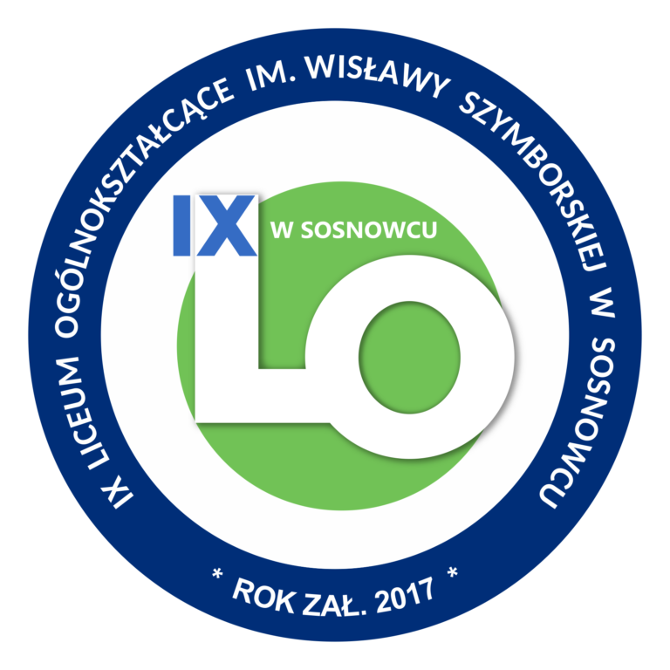
C-6 (SELF-MANAGERS)

LTT Activities in IX Liceum Ogólnokształcące im. W. Szymborskiej w Sosnowcu

2020-1-PL01-KA229-082145
helPing and Learning wiThout borderS
05 - 09.12.2022.
MOTTO: LEARNING IS ABOUT TAKING RESPONSIBILITY FOR WHAT YOU ARE DOING. THINK FURTHER THAN TOMORROW.

SATURDAY
23.30 flight LH1362 | 3 teachers and 5 students land from Madeira - Katowice Airport
11:05 flight FR6356 | 2 teachers and 4 students land from Spain -Kraków Balice Airport
SUNDAY
18:00 flight AY1165 | 2 teachers and 4 students land from Finland - Kraków Balice Airport
11:05 flight FR6331 | 2 teachers and 3 students land from Greece - Kraków Balice Airport
21:40 flight FR 6233 | 2 teachers and 5 students land from Italy - Kraków Balice Airport
MONDAY
5.12.
9:00 - 9:20 | Official welcome at school by the school Principal.
9:30 - 10:30 | Integration workshops for students.  Teachers - tour around the school.
10:40- 11:40 | Presentation of the PLTS Posters on What it means to be a Self-Manager: Golden Rules and Learnish Expressions, followed by a Teamwork (Cooperative Learning) - students in mixed teams discuss and write down the practical examples of being a self-manager in the area of: emotions, time, energy, and space. Final product - posters.
12:10- 12:45 | Lunch at school - all the project students.
 | Afternoon spent with host families.
TUESDAY
6.12.
9:00 -10:15 | Practical workshops on being a self-manager with the school psychologist - mindfulness, managing stress in everyday life situations for students.
10:30 -10:50 | Tea time.
11:00 | Departure for Osikowa Dolina
12:00-14:30 | Creativity Workshops in Osikowa Dolina - making a Christmas tree from the regional wood. Learning about the culture of the region.
15:00 -16:00 | Lunch
17:00-18:00 | Museum Education. Visiting Silesian Museum in Katowice with Polish students as tour guides - learning about the history of the region.
 | Evening with the host families.
WEDNESDAY
7.12.
7:00 - 20:00 | Outdoor education. Experiencing the culture of the region. Learning about Polish history. All day trip to Wieliczka Salt Mine and Kraków with English speaking guides. Lunch in Kraków.
THURSDAY
8.12.
7:30 - 12:30 | Educational visit to Auschwitz Concentration Camp with a tour guide. Reflection time and discussion- What a place like Auschwitz can teach us today.
12:50 -13:30 | Lunch at school.
13:30 - 15:15 | How Does Air Pollution Affect Our Lifestyle, Health, The Ability To Learn, Climate And Nature? Chemistry workshops - examining water, soil and air.
FRIDAY
9.12.
9:00 - 10:35 | Festival of Six Cultures - each partner presents a national song and/or a dance, representing the country’s culture.
10:45-11:30 | Preparing Donation Stands.
11:30 -11:50 | Collecting money for people in need for Christmas.
11:50 -12:35 | Take Action - How Can I Take Care Of Fresh Air In My Town?- students work in six international teams. Each team develops a presentation that informs one of the partner schools’ local community about the air situation in their region.
12:35-12:55 | Collecting money for people in need for Christmas.
13:00-13:30 | Lunch at school.
13:50-14:35 | Farewell ceremony. Certificates. Open mike.
 | Free afternoon with the host families.
19:30 -21:20 | Educational visit to one of the most modern concert halls in Europe - NOSPR, Katowice . Experiencing supranational culture of Europe through music. - Lawrence Foster (conductor)/ Peter Jablonski (piano), Grażyna Bacewicz, Piano Concerto, Program: Carl Maria von Weber, Overture to “Der Freischutz” [The Freeshooter] , Hector Berlioz “Romeo et Juliette”, dramatic symphony, Op.17 (selection).
SATURDAY
8:45 | Finnish team leaves from Kraków-Balice airport. Departure from Sosnowiec at 5:30 a.m. Flight AY1162.
11:30 | Spanish team leaves from Kraków-Balice airport. Departure from Sosnowiec at 8:00 a.m. Flight FR6355 .
SUNDAY
6:25 | Madeiran team leaves from Katowice airport. Departure from Sosnowiec at 4:00 a.m. Flight LH1363.
11:30 | Greek team leaves from Kraków-Balice airport. Departure from Sosnowiec at 8:00 a.m. Flight FR6328.
16:30 | Italian team leaves from Kraków-Balice airport. Departure from Sosnowiec in a mini-bus at 12:45 Flight FR6232.

