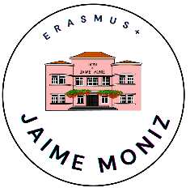
ESCOLA SECUNDÁRIA
JAIME MONIZ

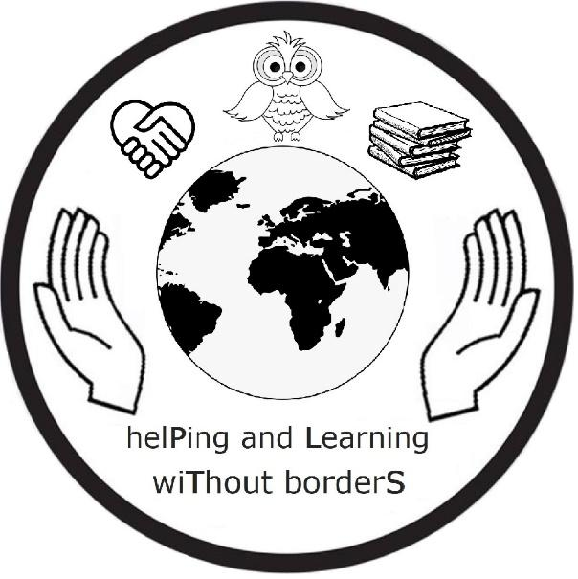
Erasmus+ Project 2020-1-PL01-KA229-082145_3
C1 – Independent Enquirers
FUNCHAL, MADEIRA - 06.03.2023 - 10.03.2023

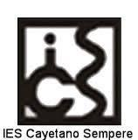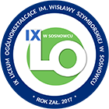
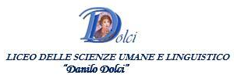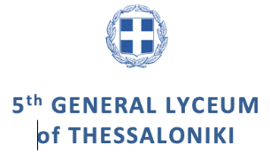

EVALUATION REPORT
AFTER C1 – Independent Enquirers
Link to questionnaire – https://forms.gle/a5trmwNTfH6DhMXr7
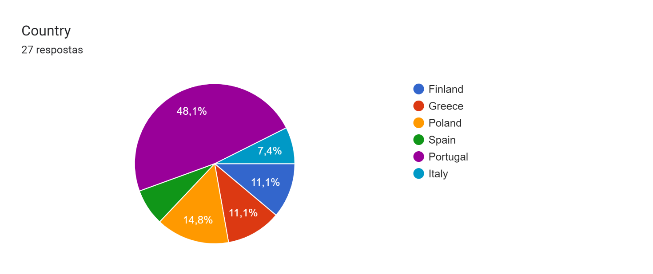
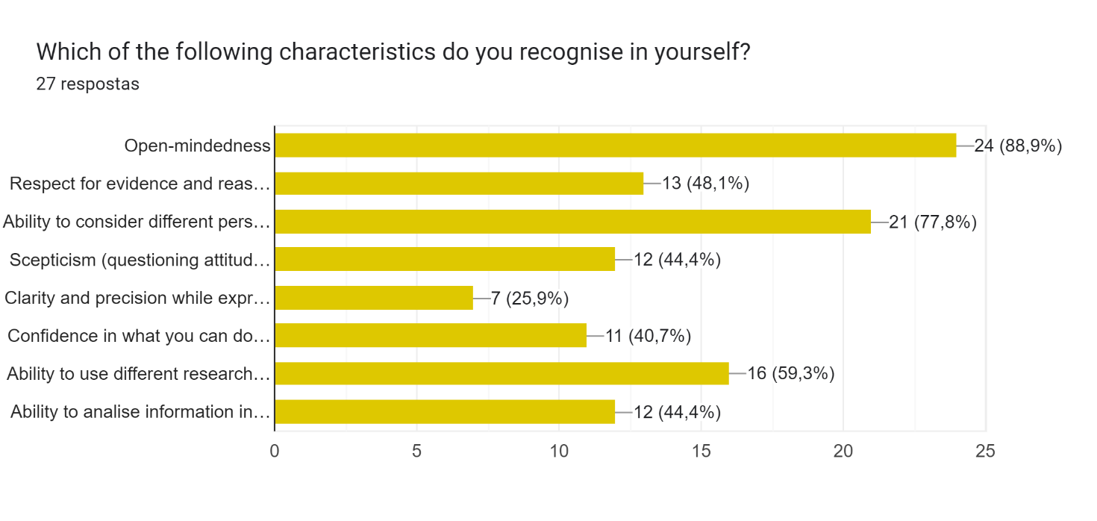
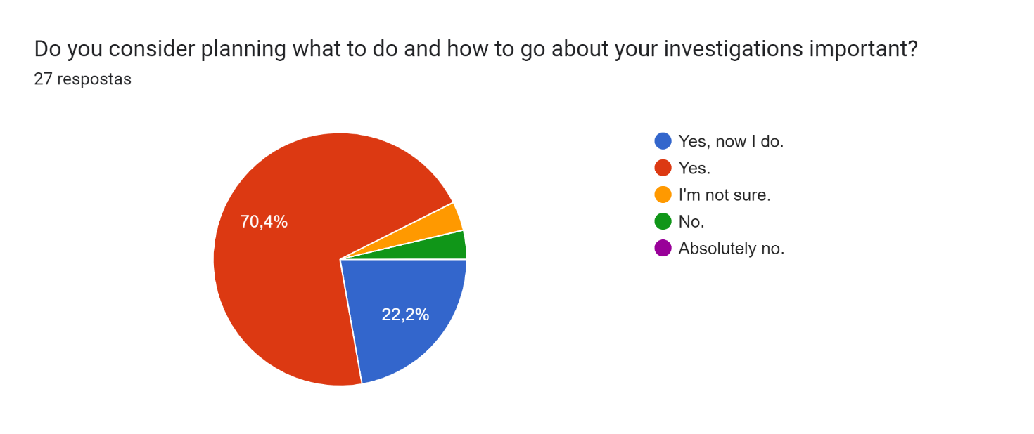
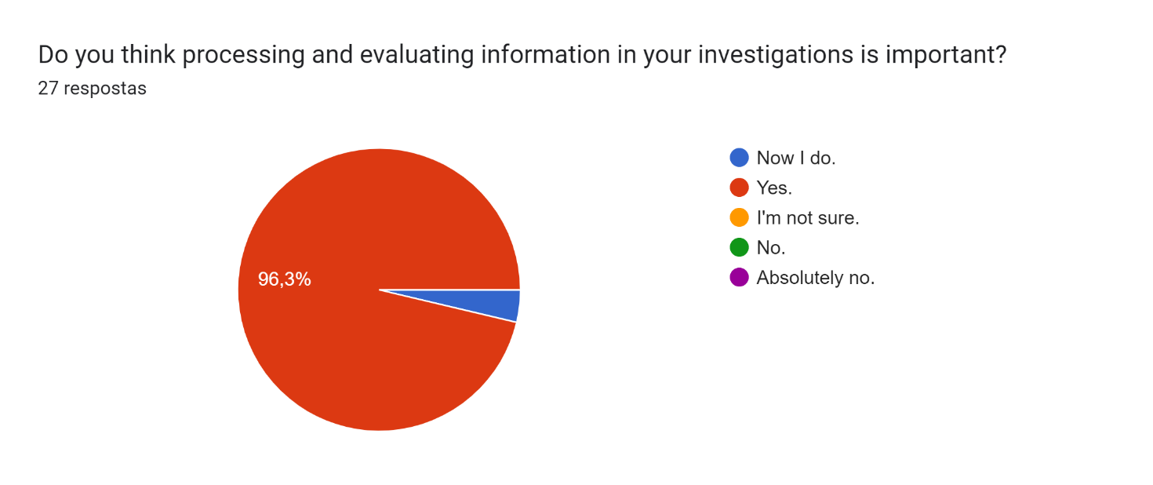
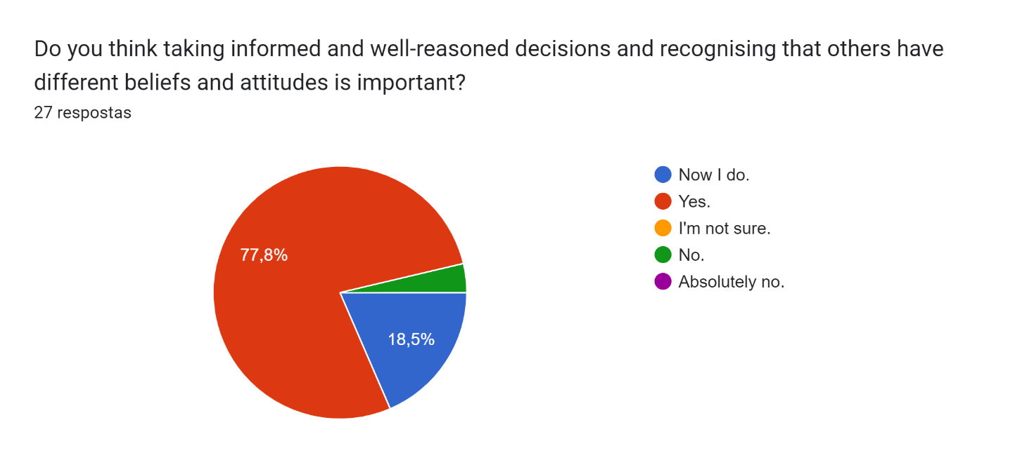
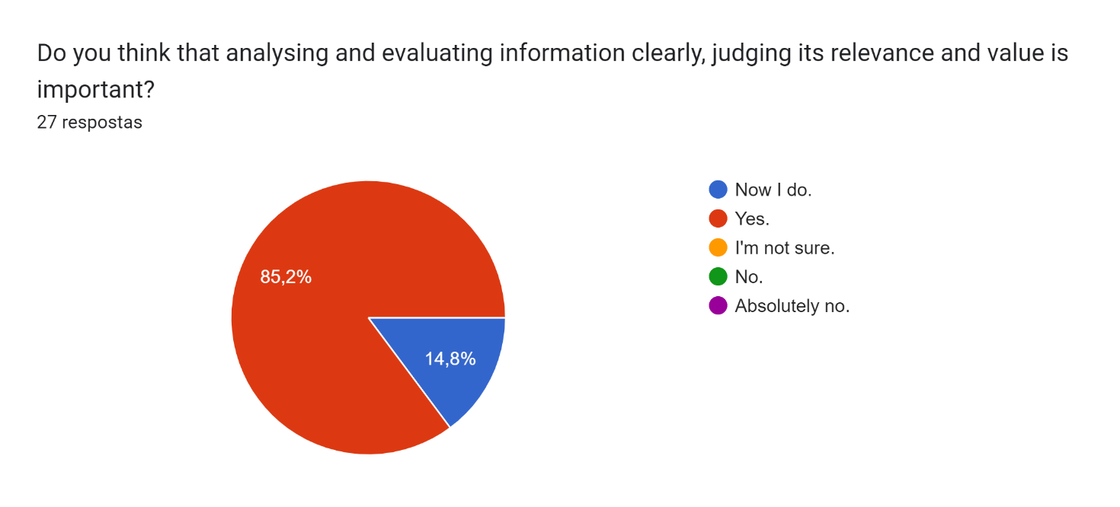
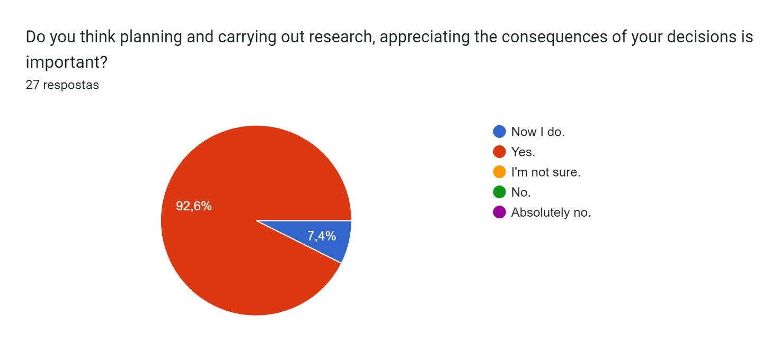
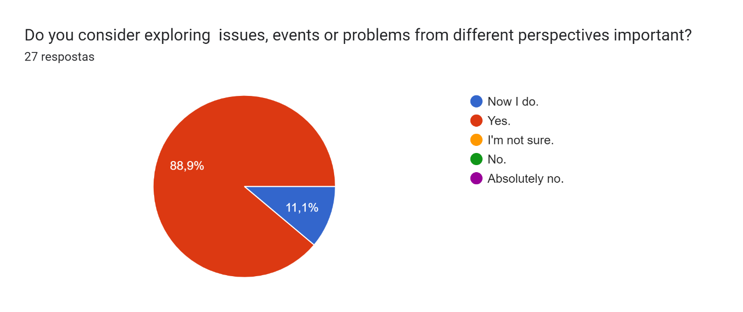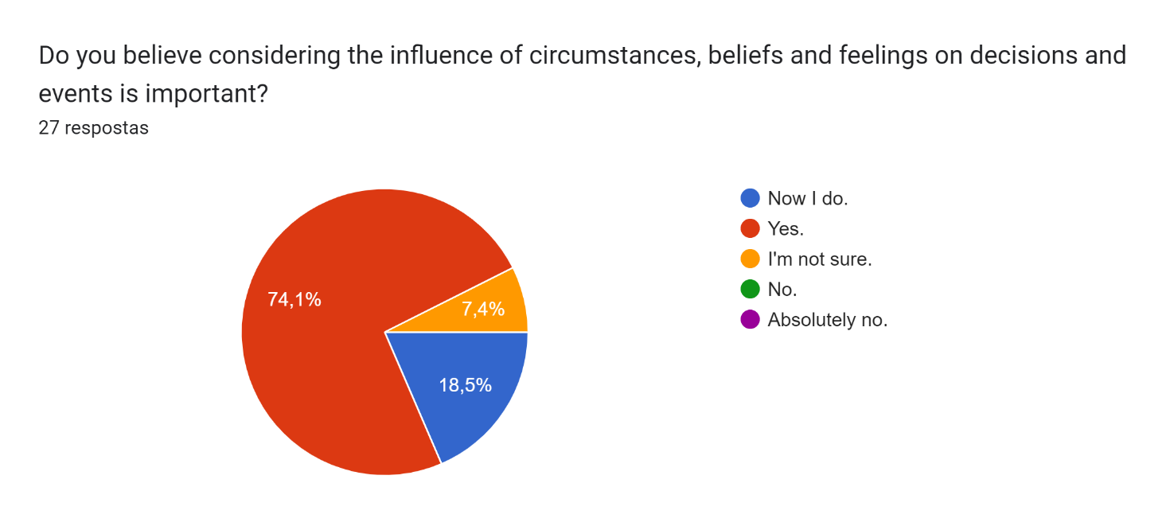
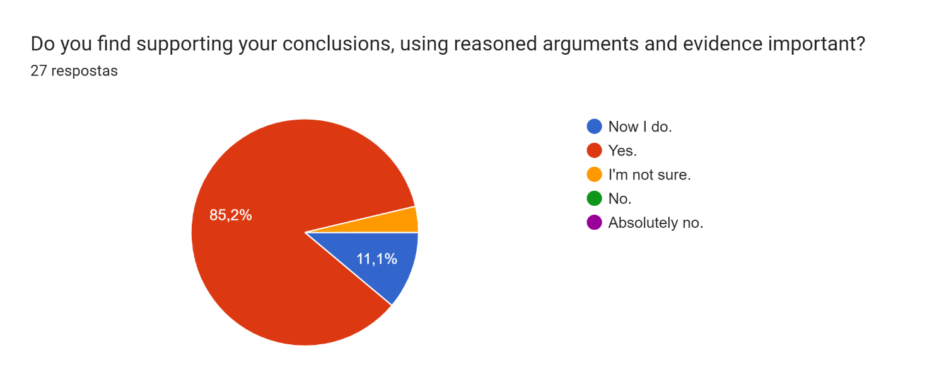
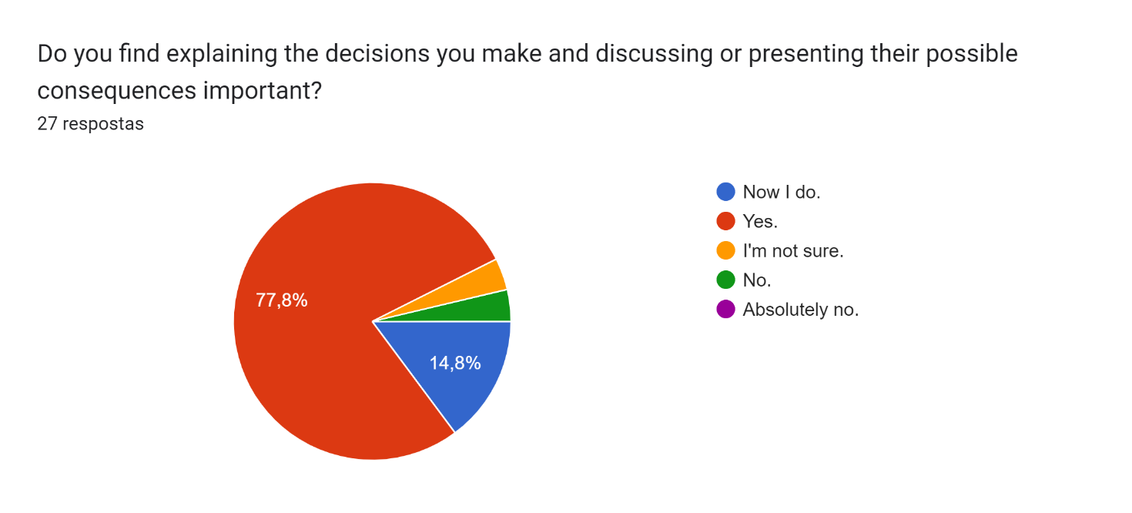

AFTER C1 – Mobility Evaluation – Students
Link to questionnaire – https://forms.gle/cg7xJxcH1h6Fzi5M6

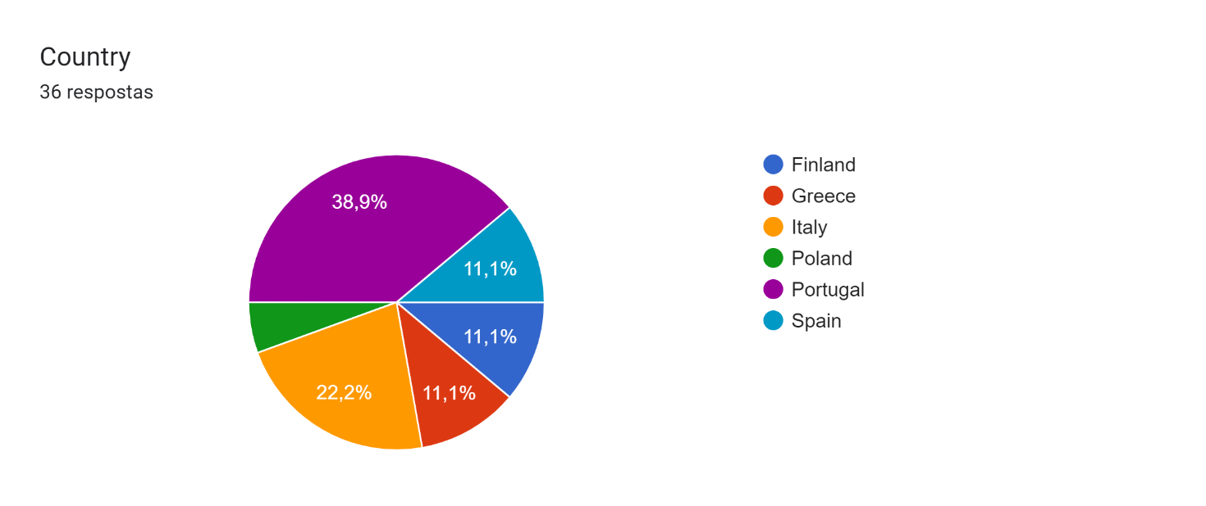

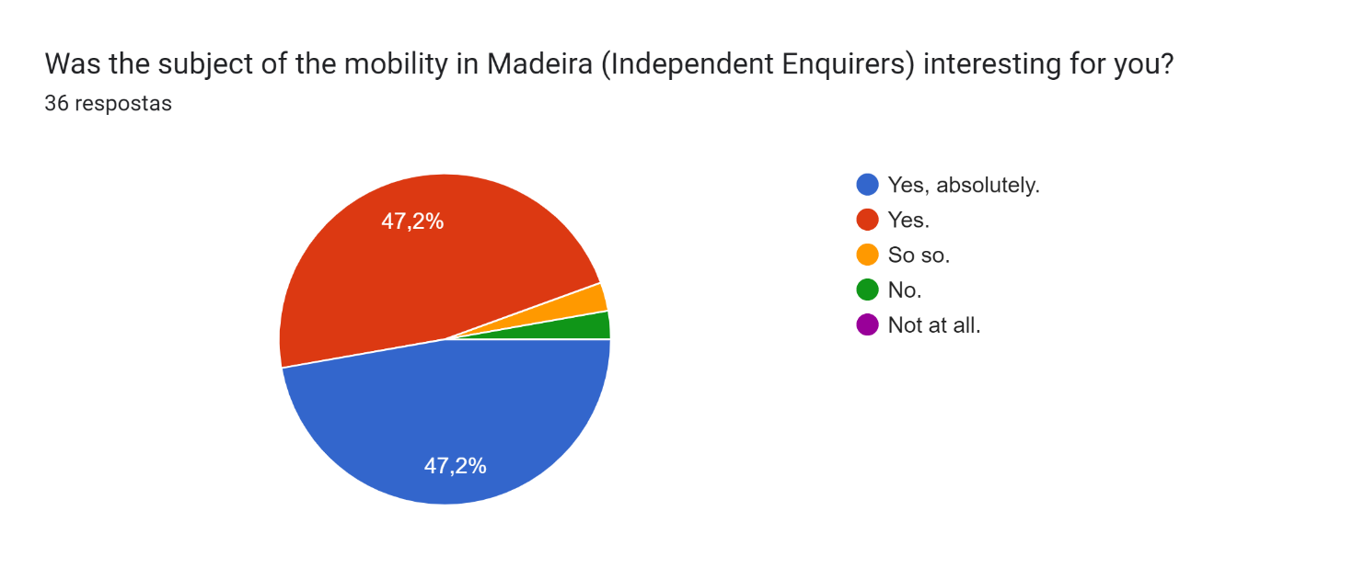

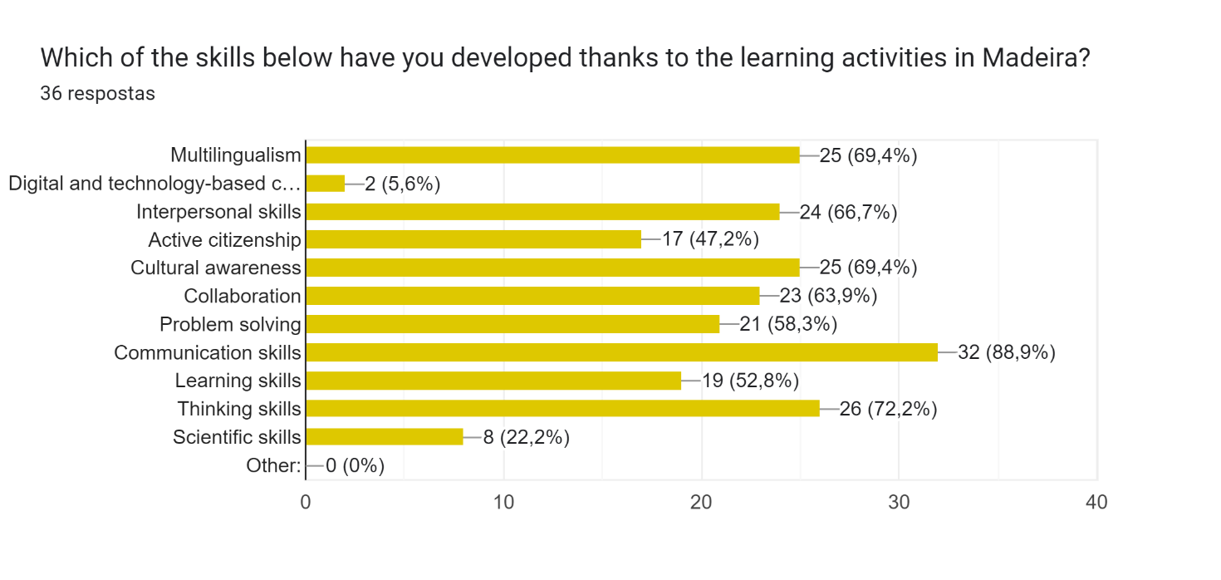
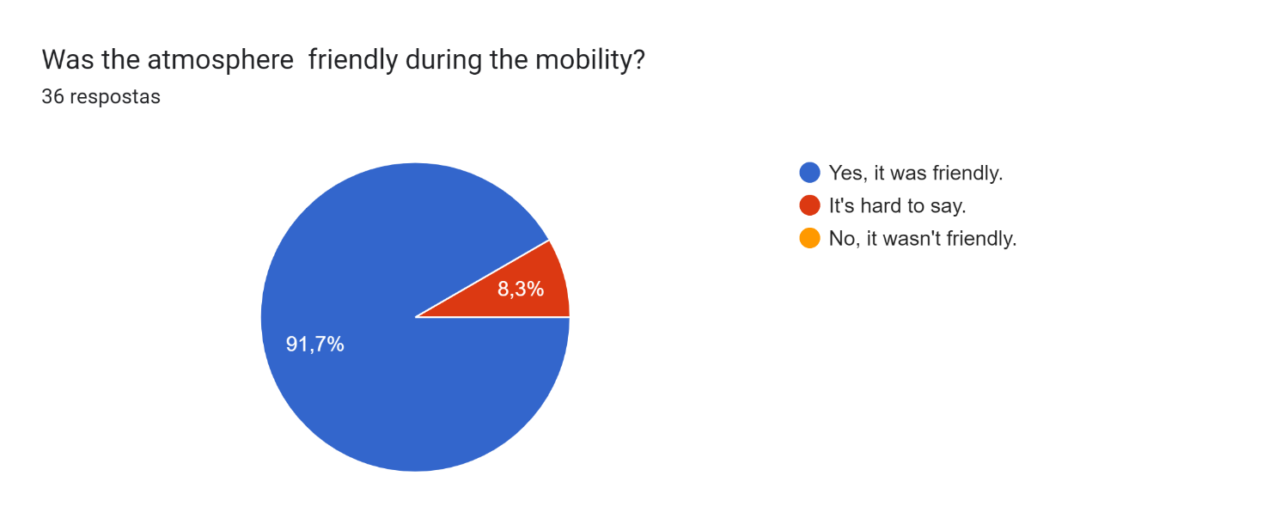
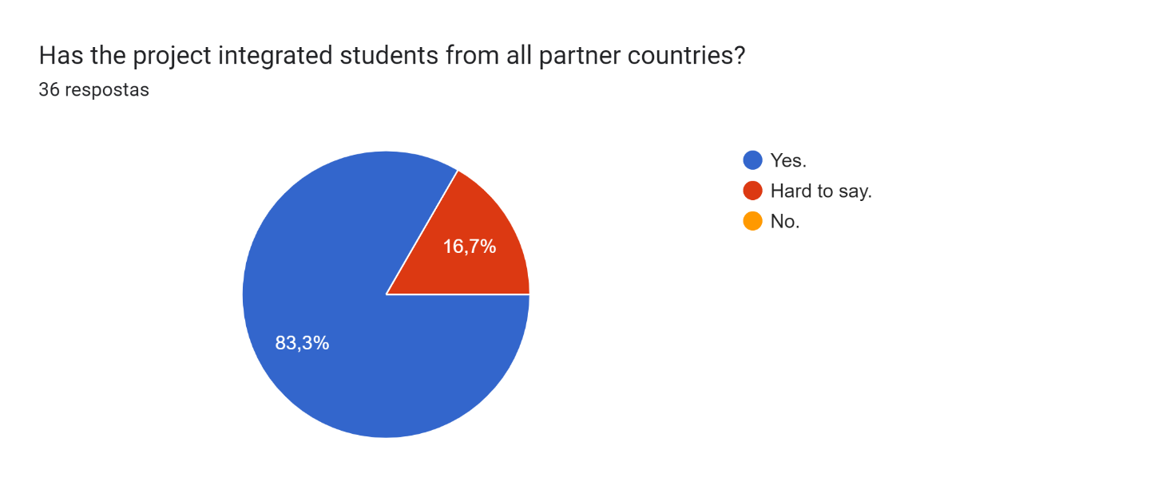
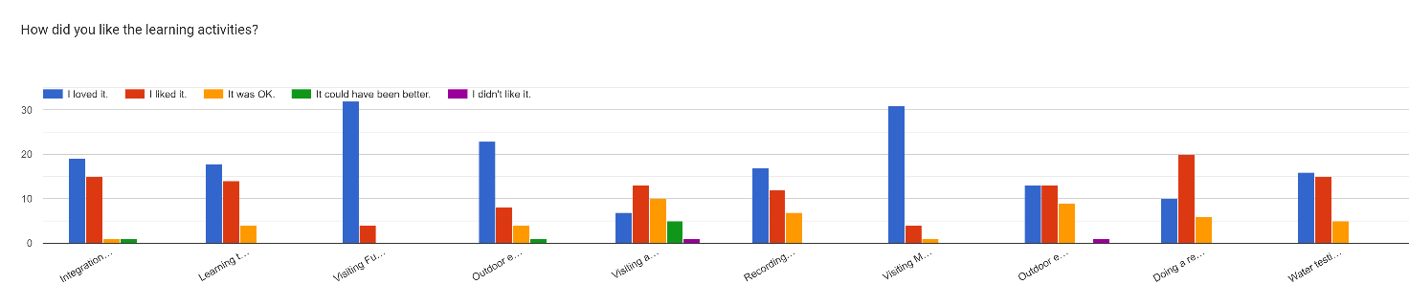
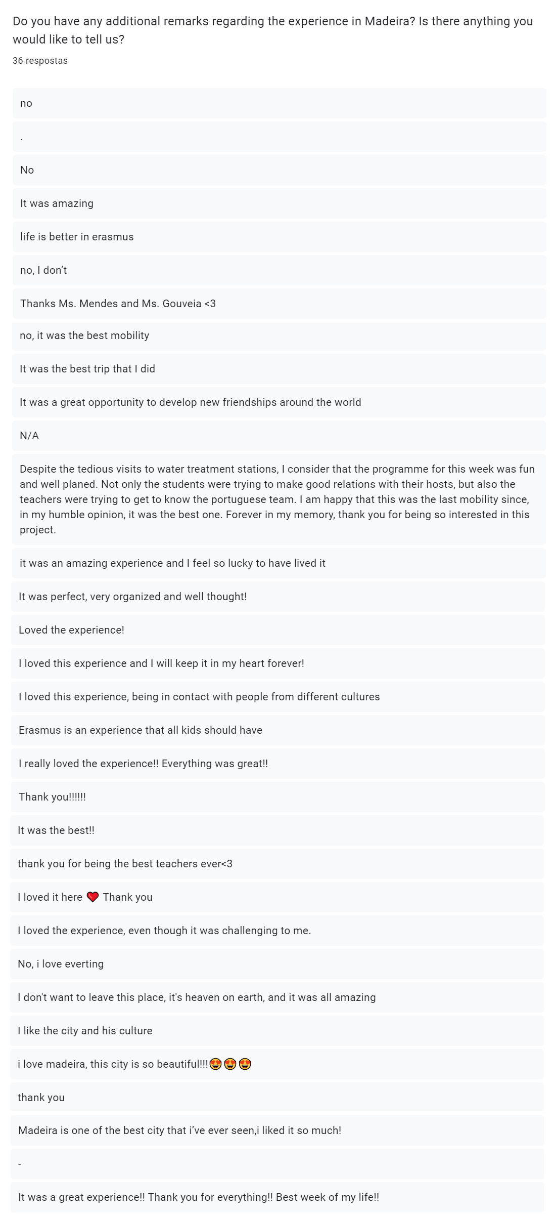
AFTER C1 – Mobility Evaluation – Accompanying Teachers
Link to questionnaire – https://forms.gle/PLAAf7CNzi4z9kv47
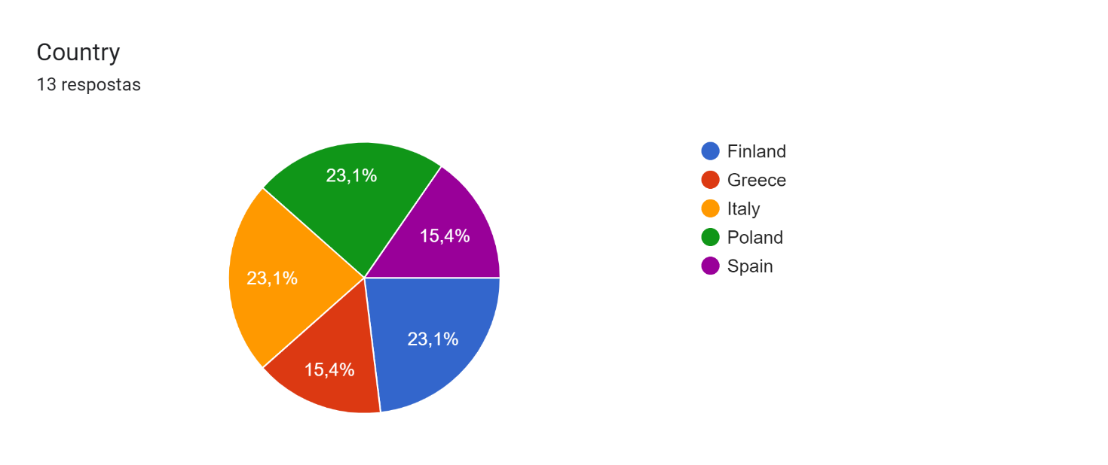
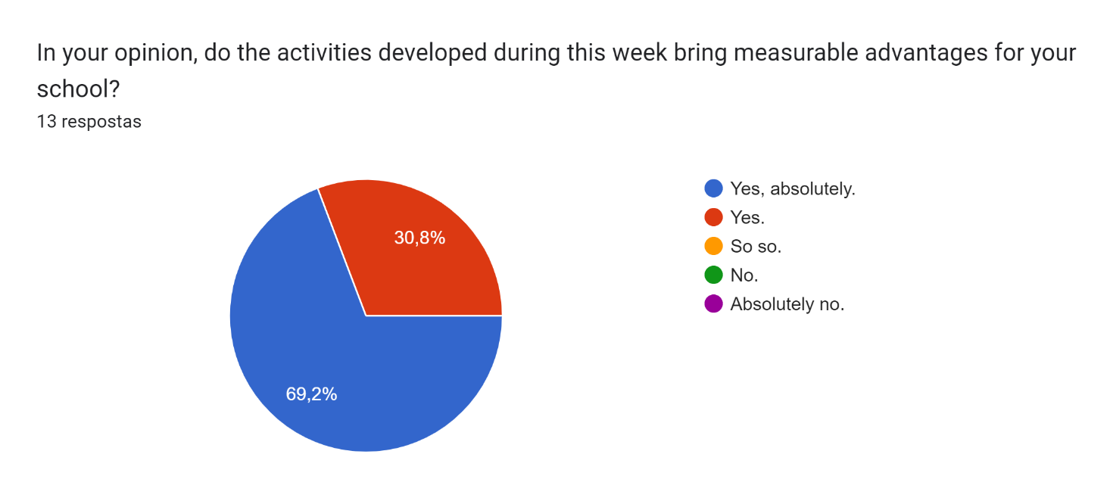
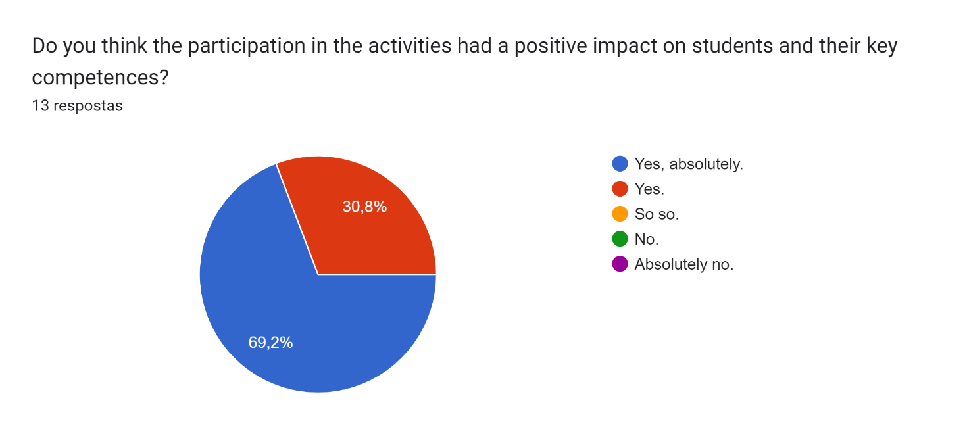
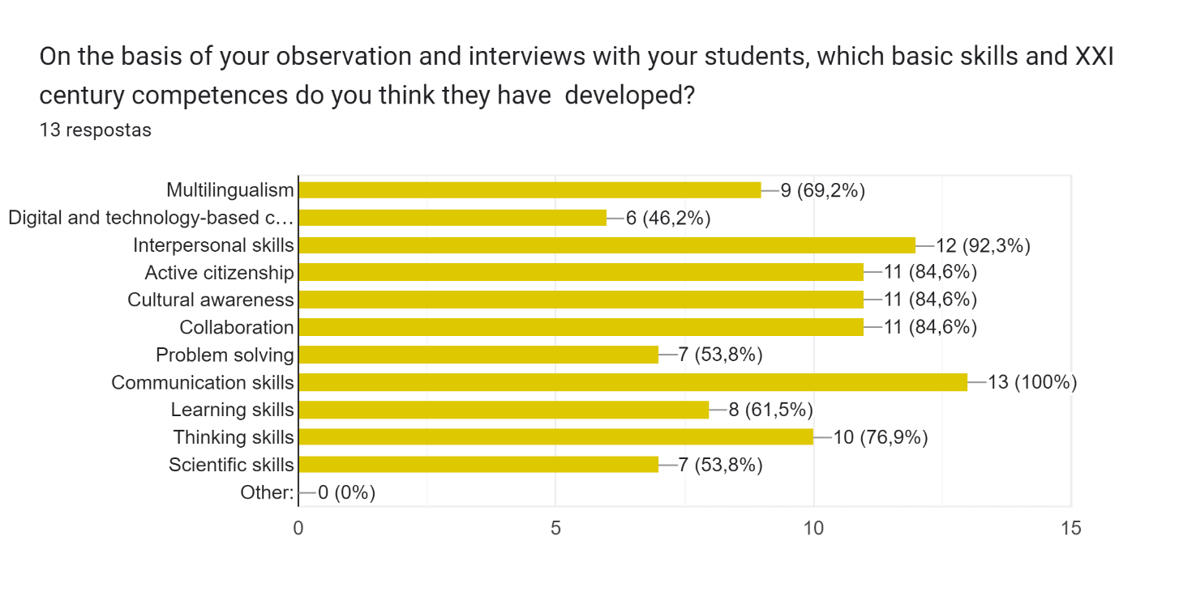
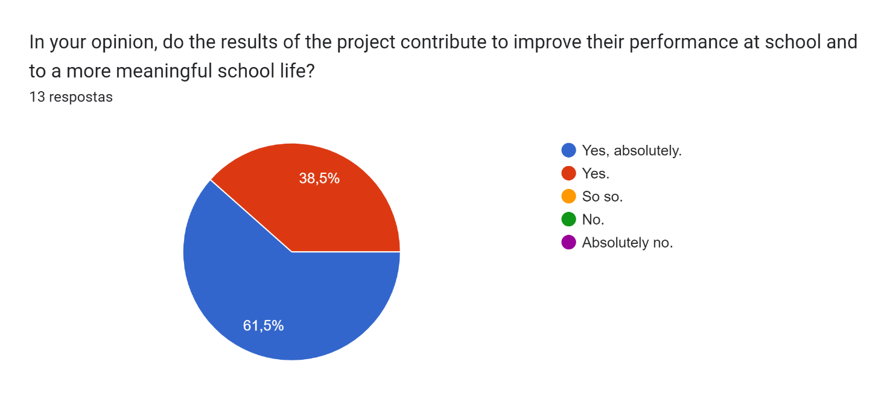
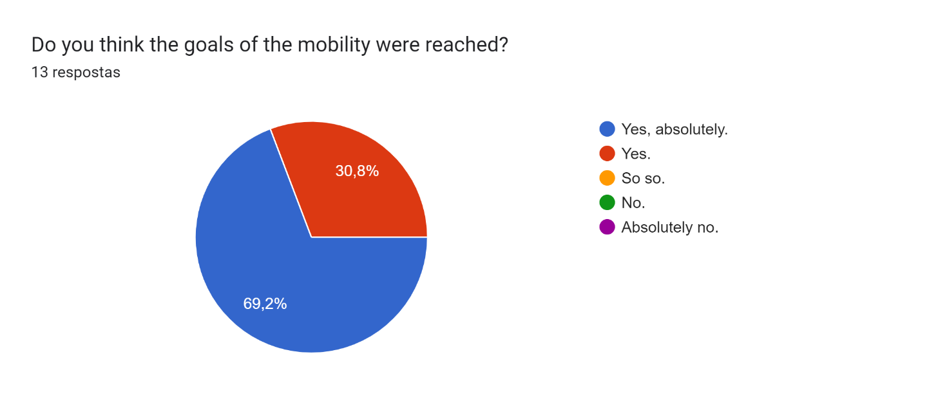
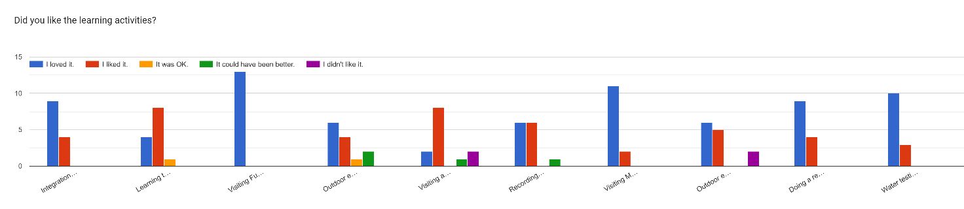
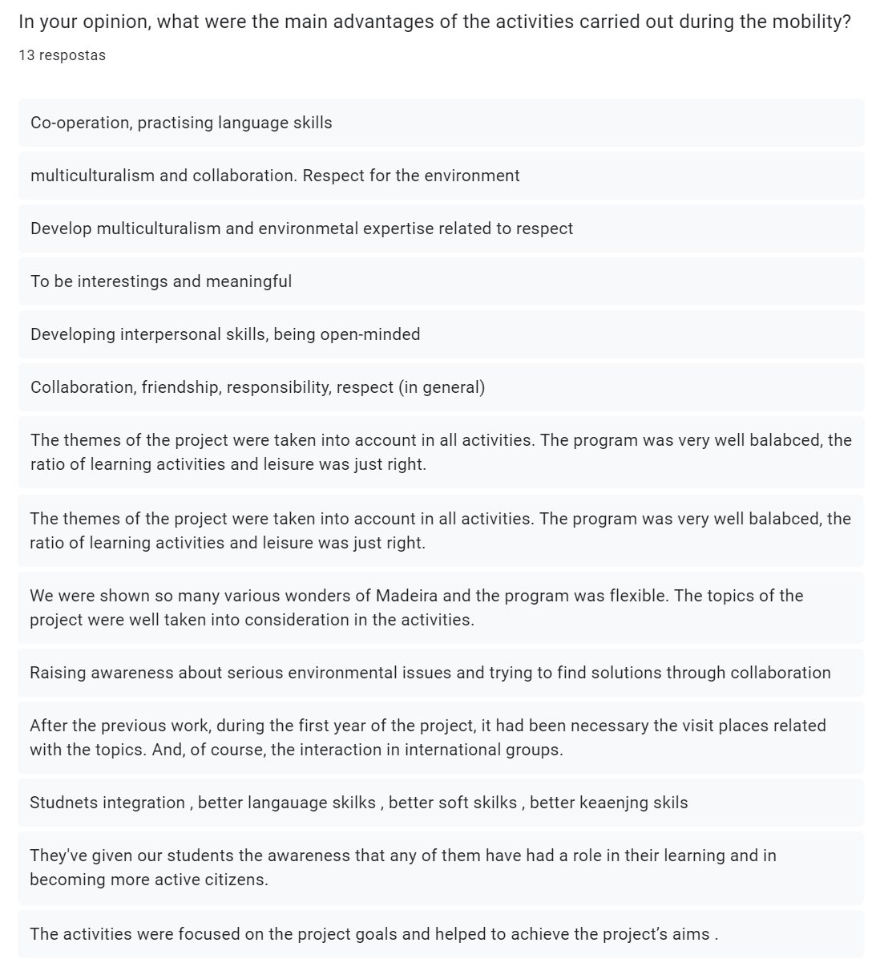

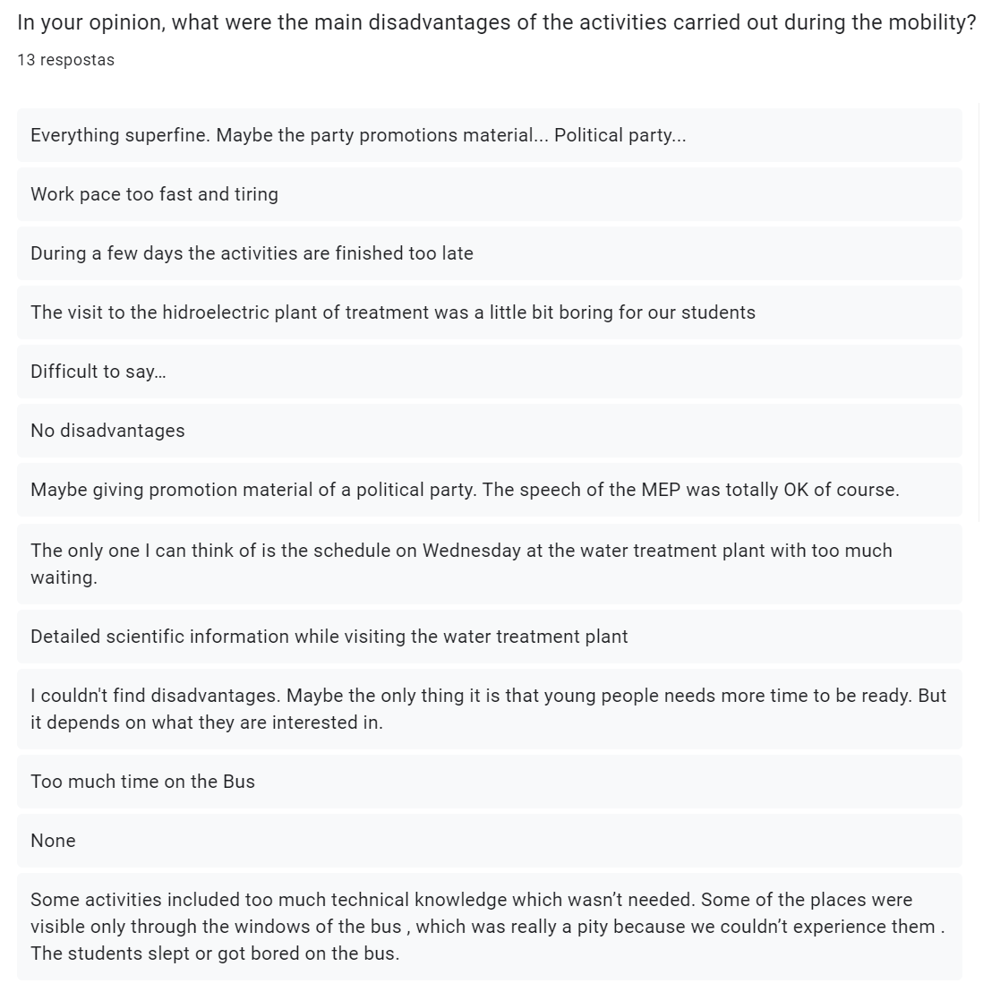

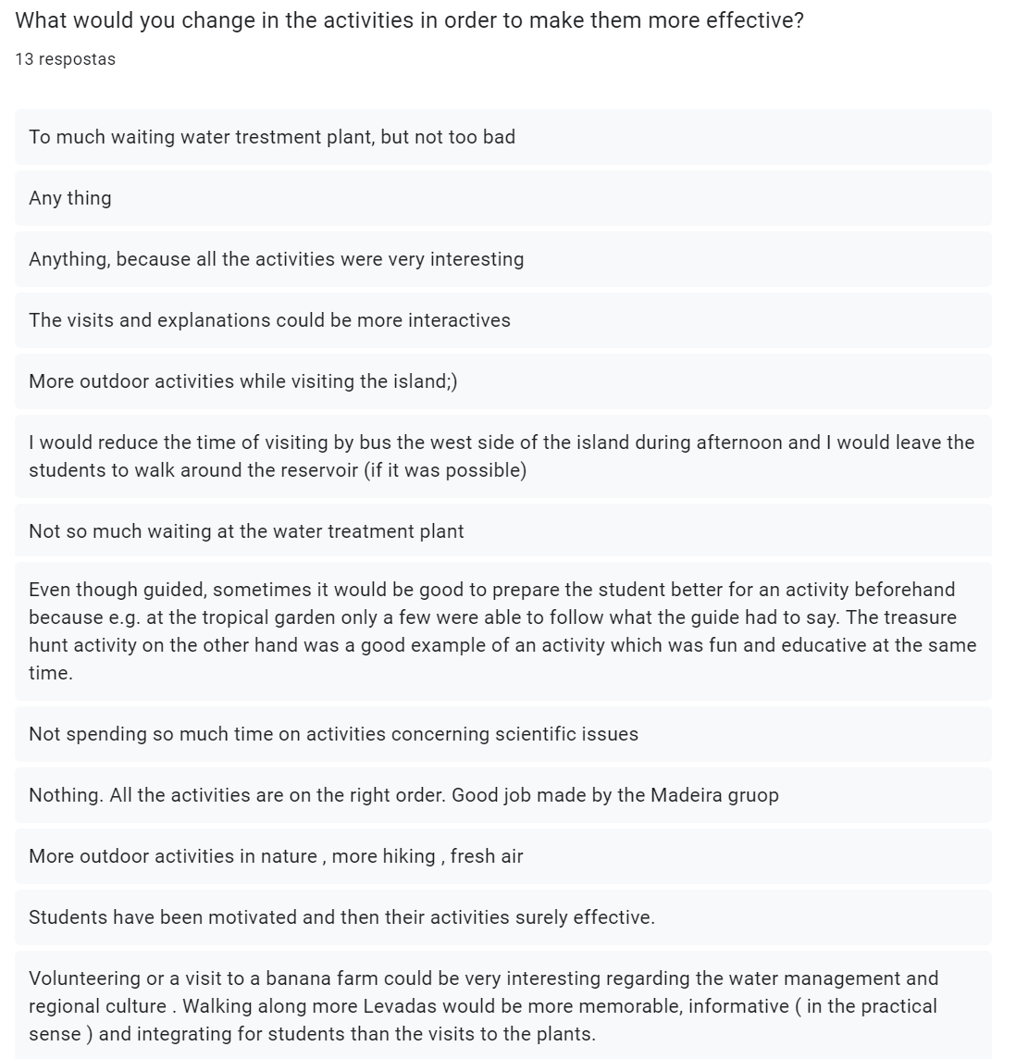

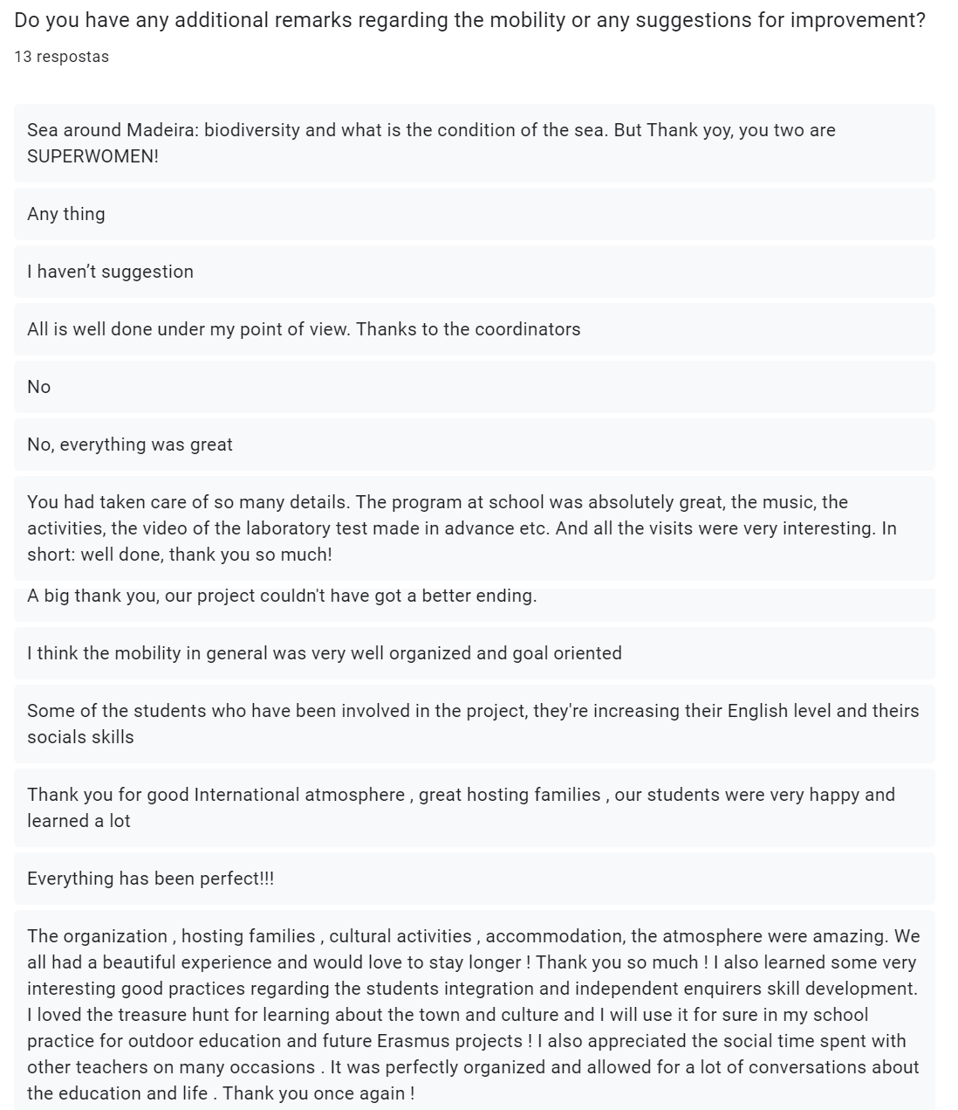

CONCLUSIONS:
We consider that the goals of the C1 LTTA in Funchal, Madeira, Portugal have been achieved.
After having discussed the meaning of being an independent enquirer and having decided on the rules and expressions for being one, a vast majority of students states that they either already follow the precepts involved in the concept or have learned to do it. There is still a minority (one or two students) who does not attach importance to the aspects listed below, which shows us that, while most have grasped the ideas, the Learning2Learn-related activities must be the object of ongoing discussion.
- Do you consider planning what to do and how to go about your investigations important?
- Do you think taking informed and well-reasoned decisions and recognising that others have different beliefs and attitudes is important?
- Do you believe considering the influence of circumstances, beliefs and feelings on decisions and events is important?
- Do you find supporting your conclusions, using reasoned arguments and evidence important?
- Do you find explaining the decisions you make and discussing or presenting their possible consequences important?

The following list shows which skills the students consider were most developed thanks to the LTT activities:
- communication skills – 88,9%
- thinking skills – 72,2%
- multilingualism / cultural awareness – 69,4%
- interpersonal skills – 66,7%
- collaboration – 63,9%

Most of the students stated the atmosphere was friendly and that the project integrated students from all the partner countries. From all the planned activities, visiting a water treatment plant was the one the students pointed out as needing improvement. This had to do with the long waiting period and the too technical explanation provided by the engineer in charge of the visit. As we have no control over who guides the tour, the solution may be replacing this activity with another that fulfils the same goals.

As for the teachers, they consider that the activities developed during the week bring measurable advantages for their school, that participation in the activities had a positive impact on the students involved and their key competences, that the results of the project contribute to improve their performance at school and to a more meaningful school life and that the goals of the mobility were reached. As with the students, from all the planned activities, visiting a water treatment plant was the one more teachers pointed out as needing improvement.
The following list shows which skills the teachers consider were the most developed thanks to the LTT activities (and which were also the most pointed out by the students, albeit with different percentages):
- communication skills – 100%
- interpersonal skills – 92,3%
- active citizenship / cultural awareness / collaboration – 84,6%
- thinking skills – 76,9%
- multilingualism – 69,2%

All the suggestions pertaining making the activities more effective are valid and will be taken into consideration when planning activities for our students.

Funchal, 15th March, 2023

