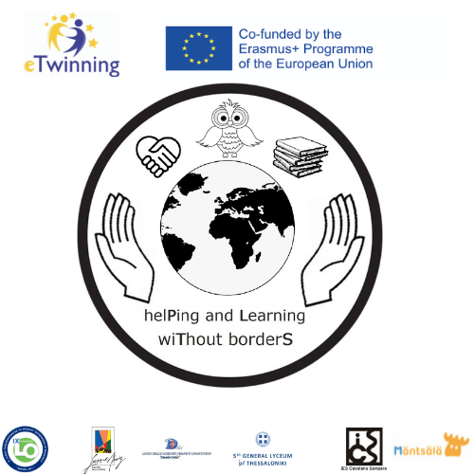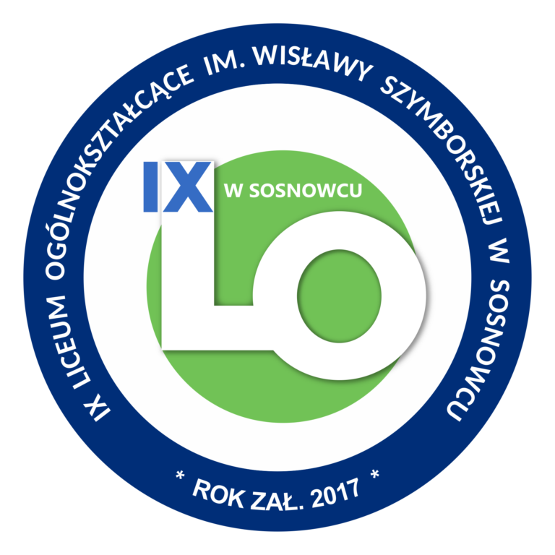
"HelPing and Learning WiThout BorderS".
2020-1-PL01-KA229-082145
EVALUATION
AFTER C-6 LTTA in SOSNOWIEC
IX Liceum Ogólnokształcące im. Wisławy Szymborskiej w Sosnowcu
5-9.12.2022.

Answers to the surveys

THE LINK TO THE ENTRY SURVEY FOR STUDENTS:
https://docs.google.com/forms/d/e/1FAIpQLSesv2Cr95w2sC_O_GBtnouyt9FUcbmyjZXJbvgXWu1eErq05w/viewform?usp=sf_link
WE RECEIVED 43 ANSWERS.
STUDENTS’ ANSWERS:

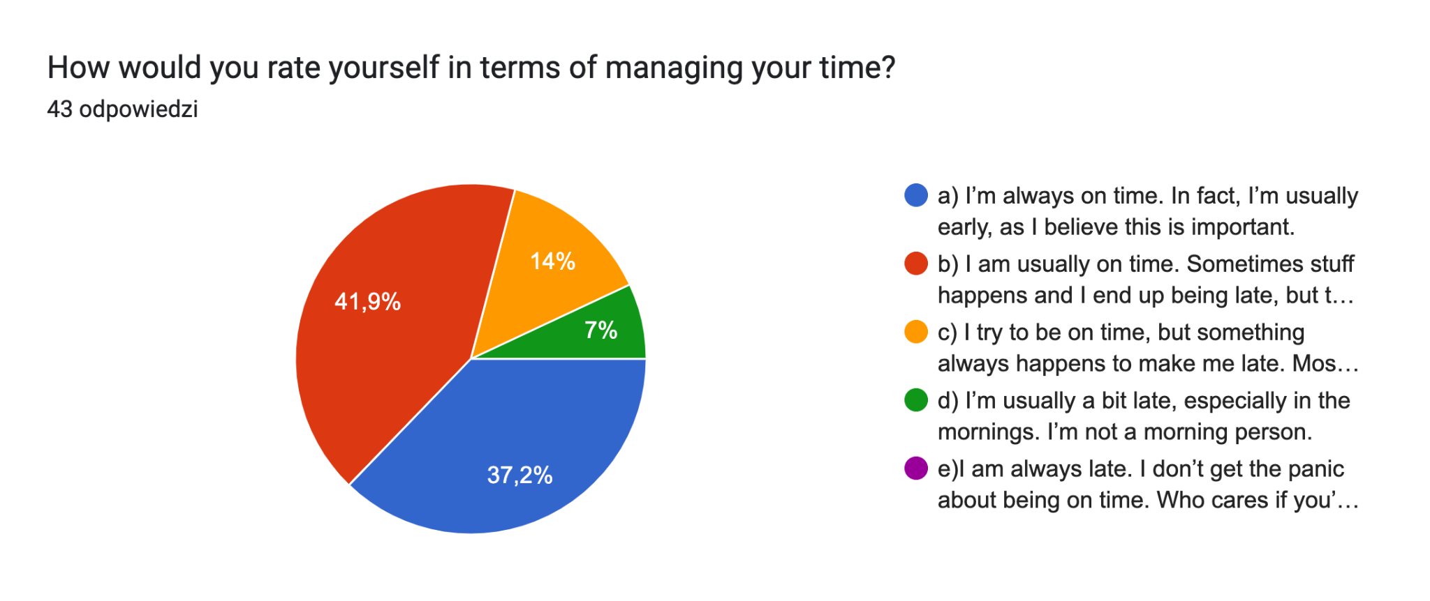
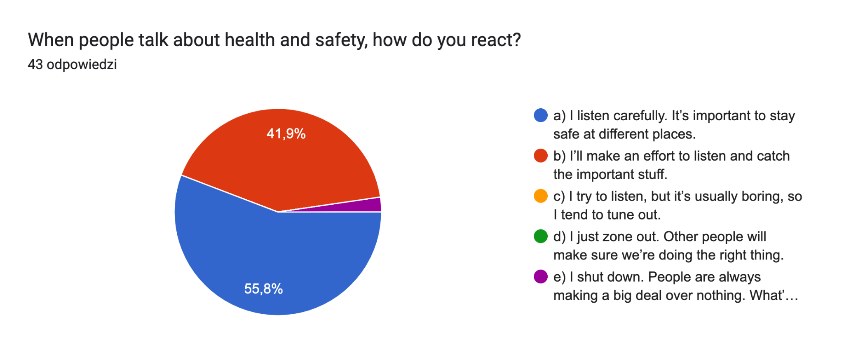
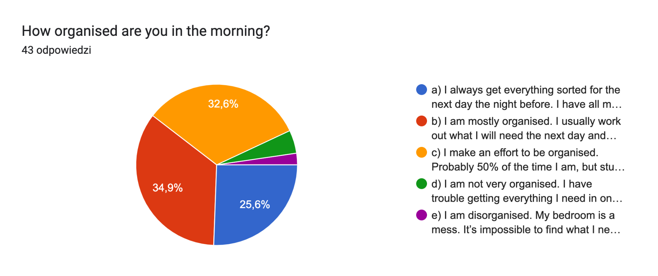
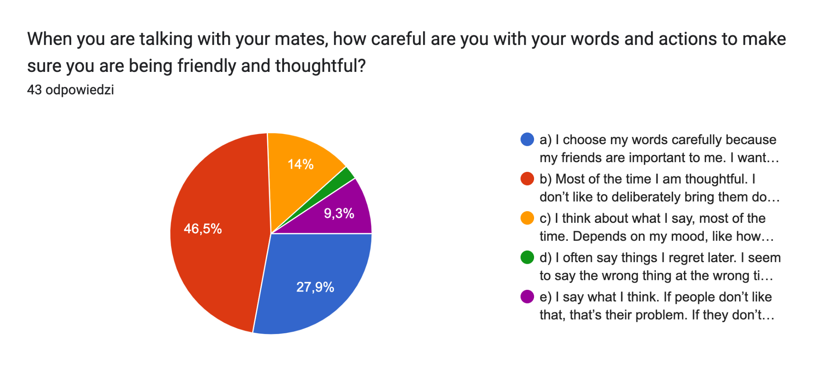
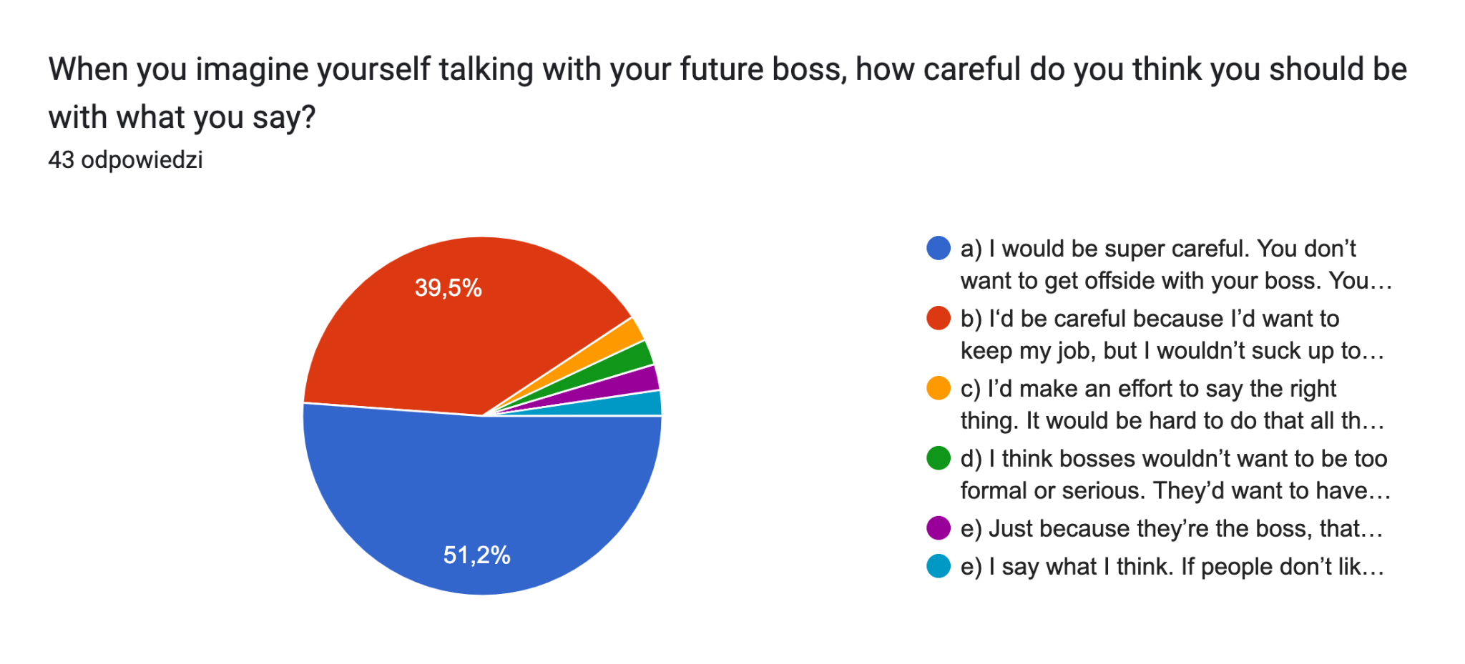
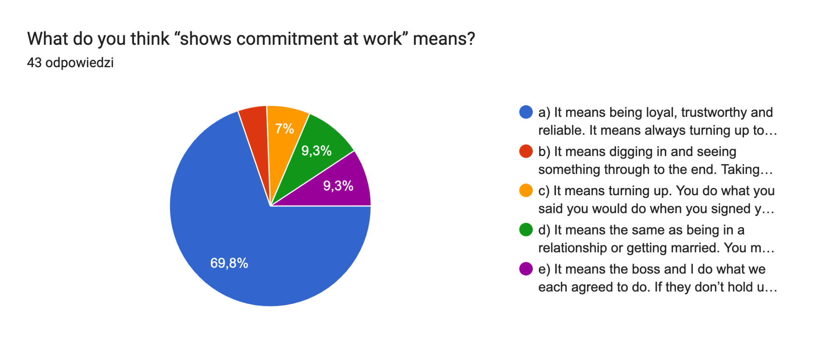
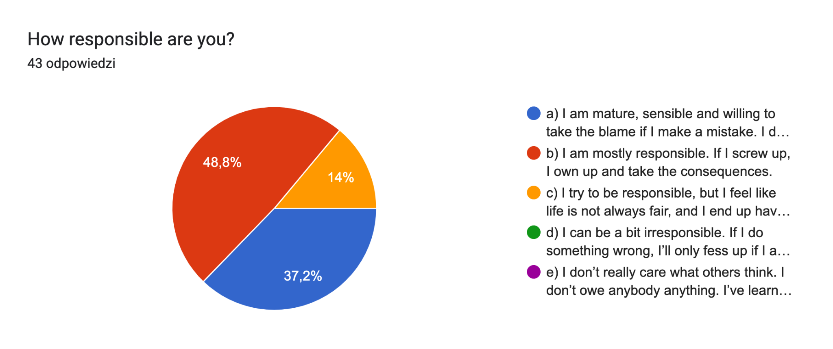
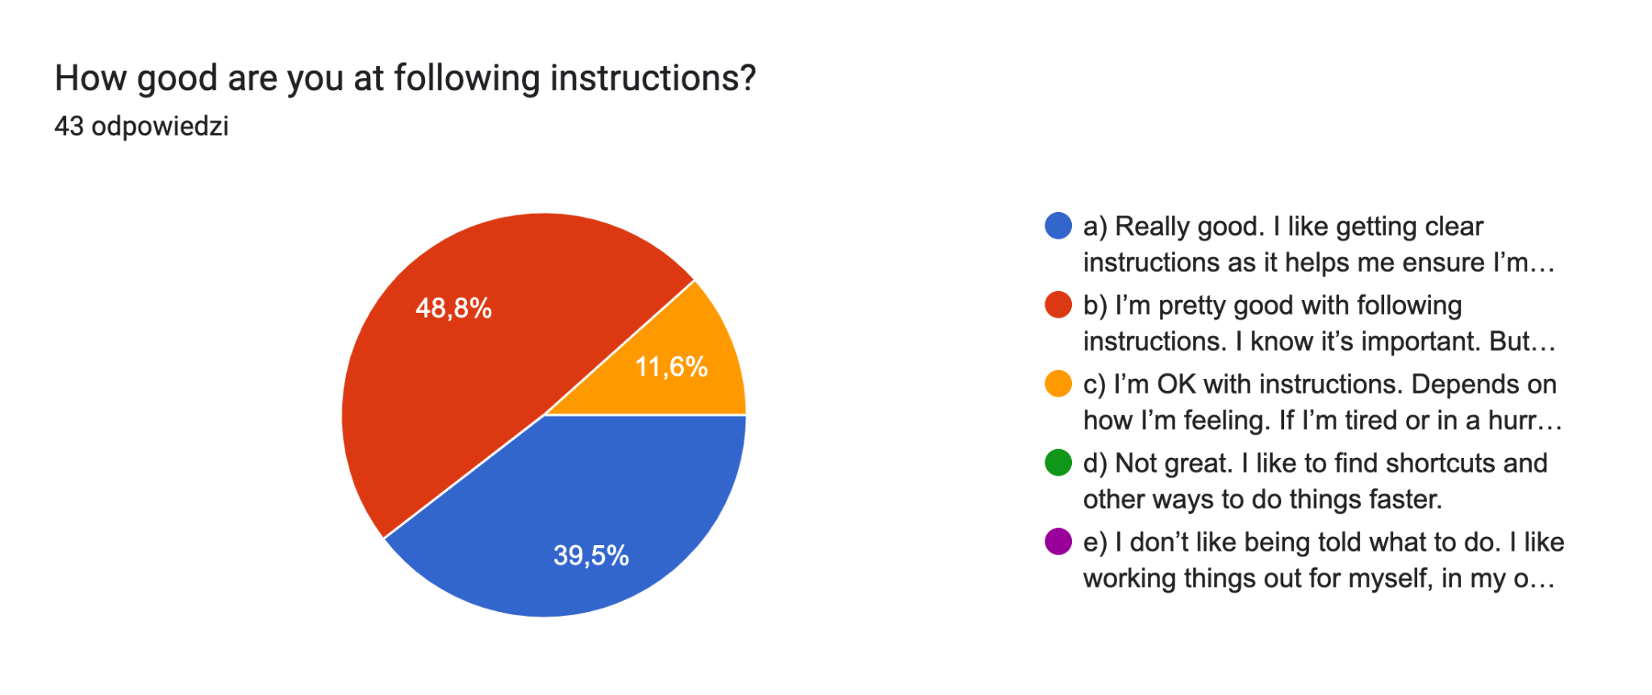
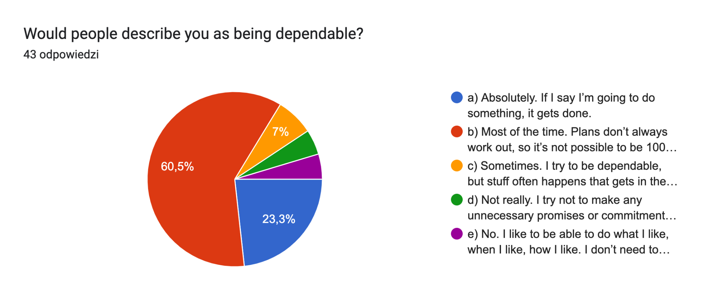
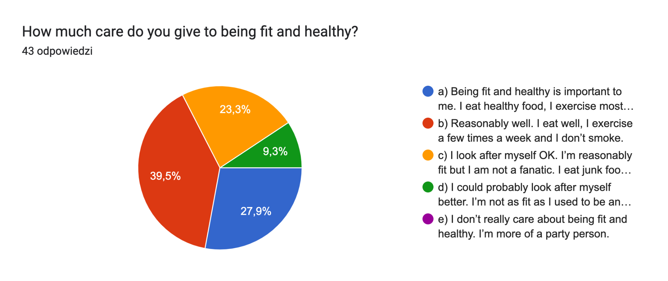

The link to the survey for STUDENTS:
https://docs.google.com/forms/d/e/1FAIpQLSeiYkumkraX3pSDtvPLbu_gqhWOG303TEM8EmX0VX8ovr_eQA/viewform?usp=sf_link
WE RECEIVED 33 ANSWERS

STUDENTS’ ANSWERS:

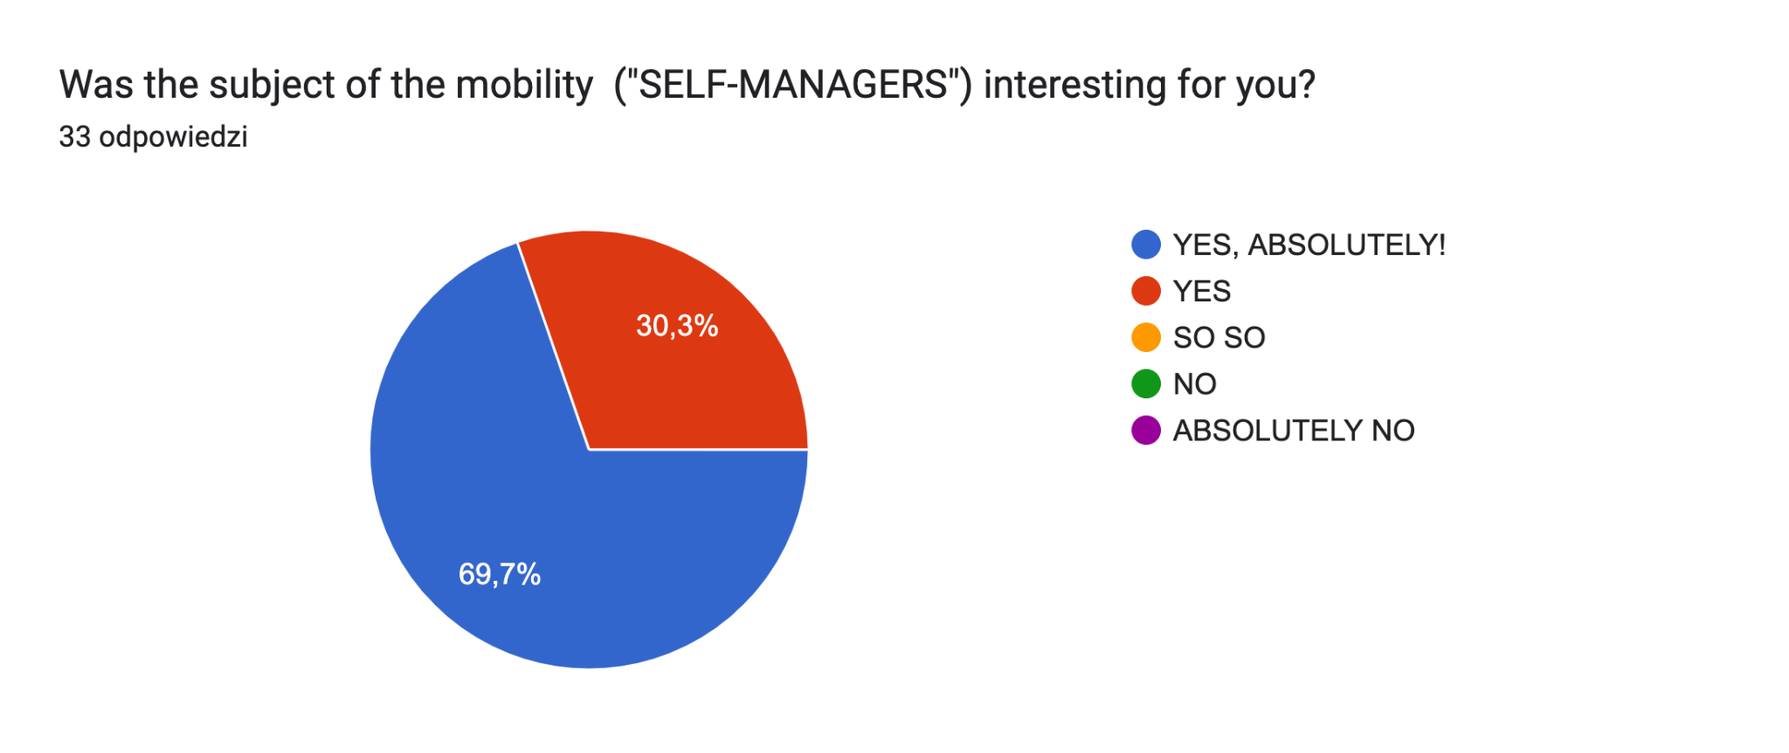
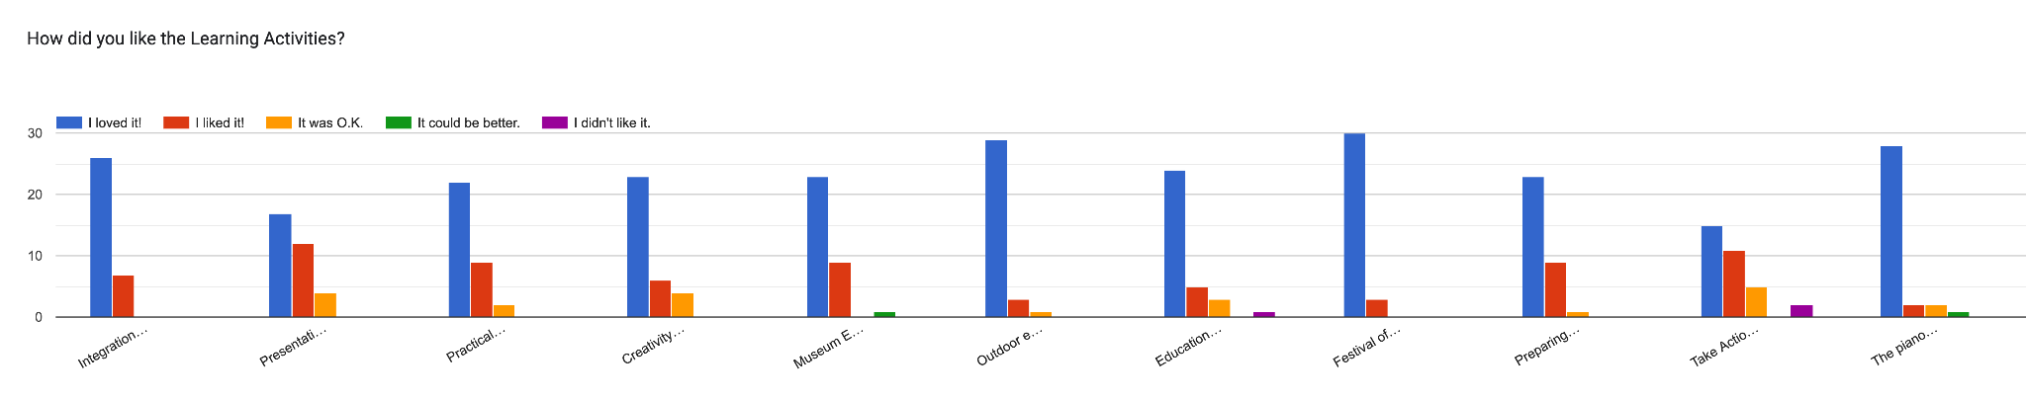
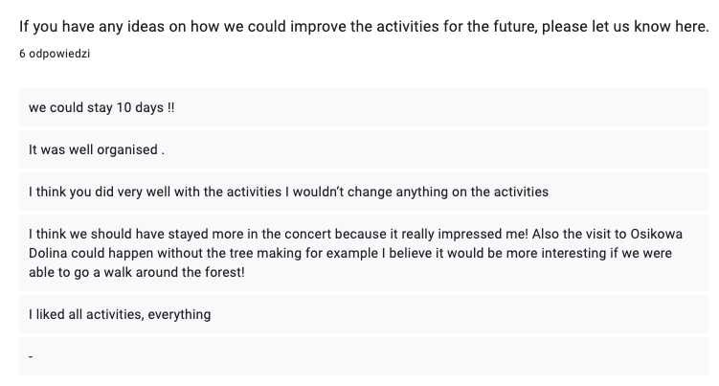
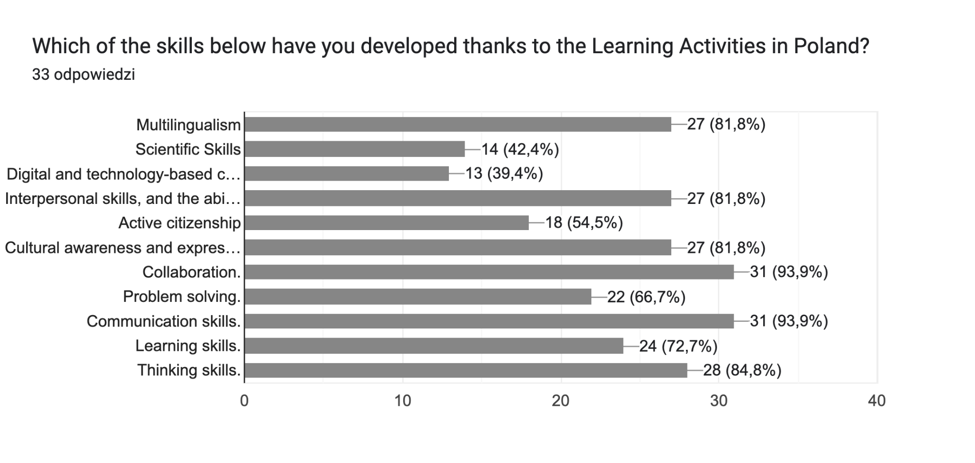
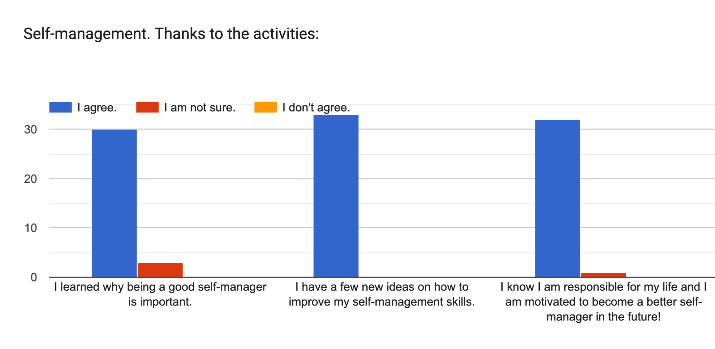
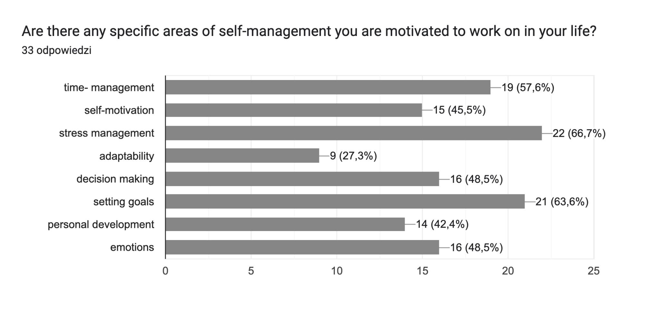
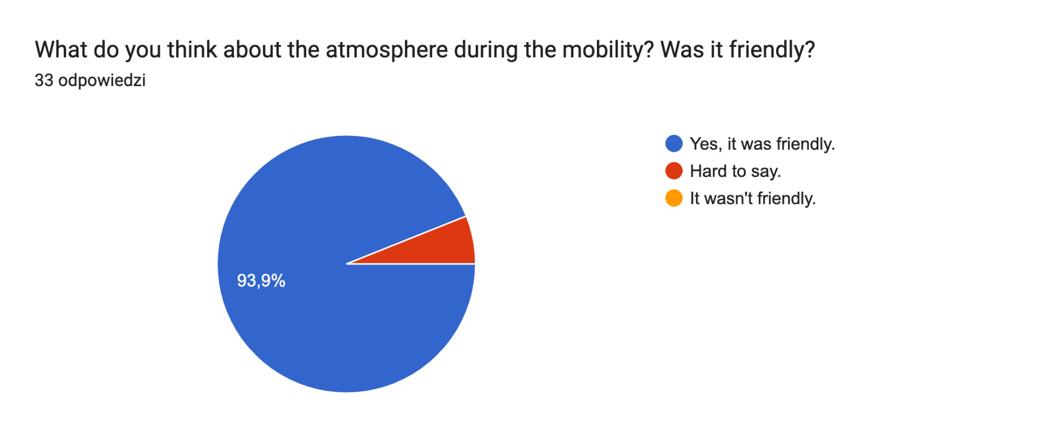
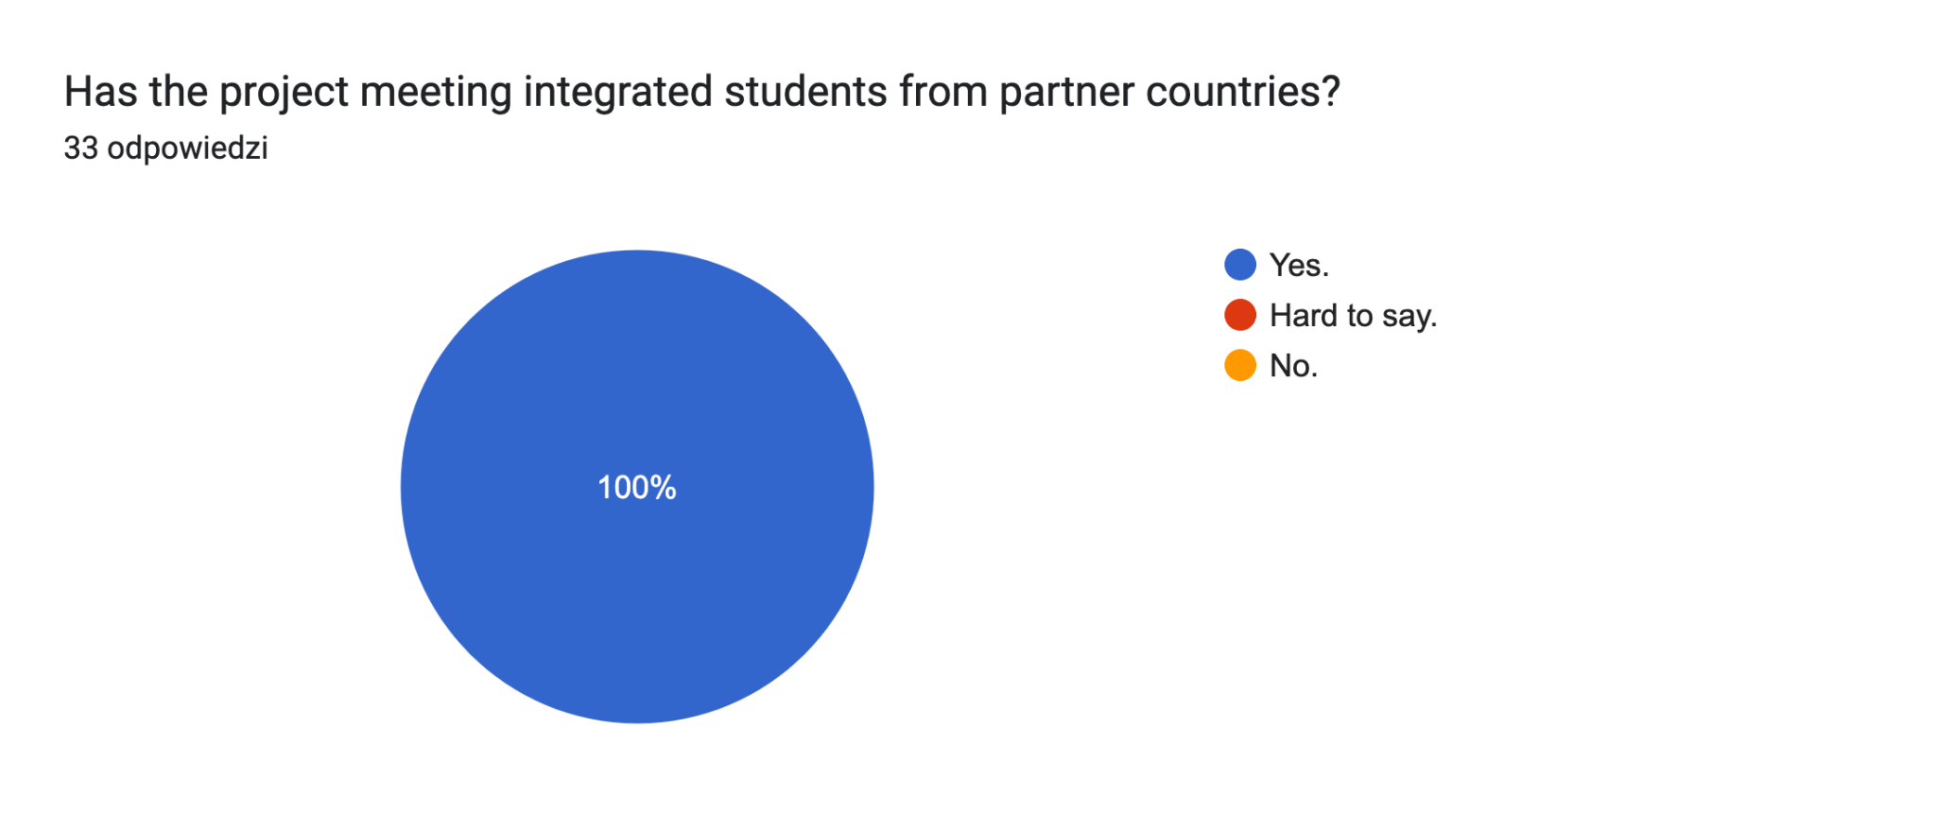
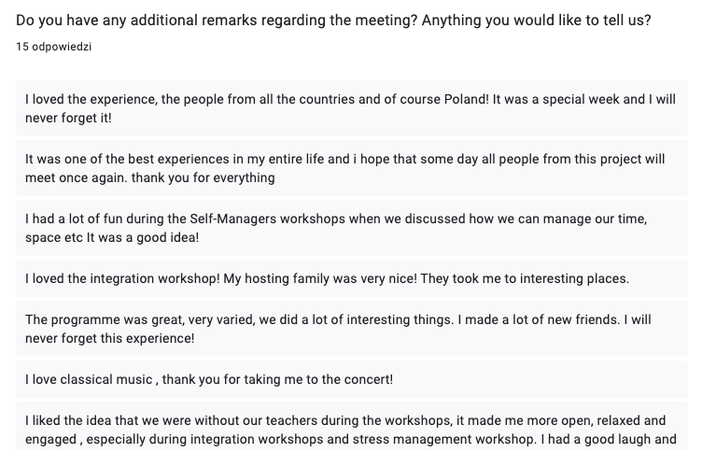
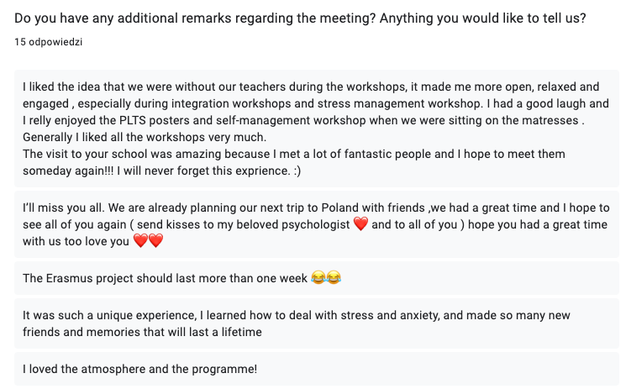
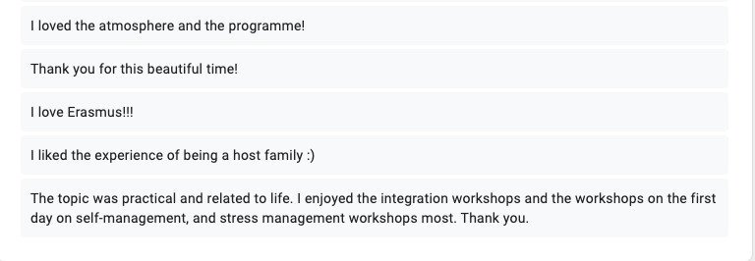

The link to the survey for TEACHERS:
https://docs.google.com/forms/d/e/1FAIpQLSd_2InuNkEg5KpQ2pnJvI_LxnYyZYo77cgDsN_a2ZHJQTtmtA/viewform?usp=sf_link
WE RECEIVED 9 ANSWERS

TEACHERS’ ANSWERS

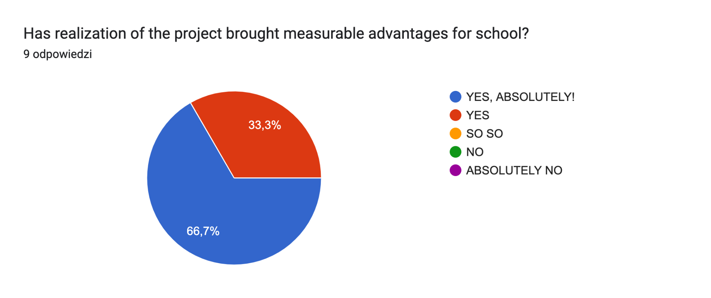
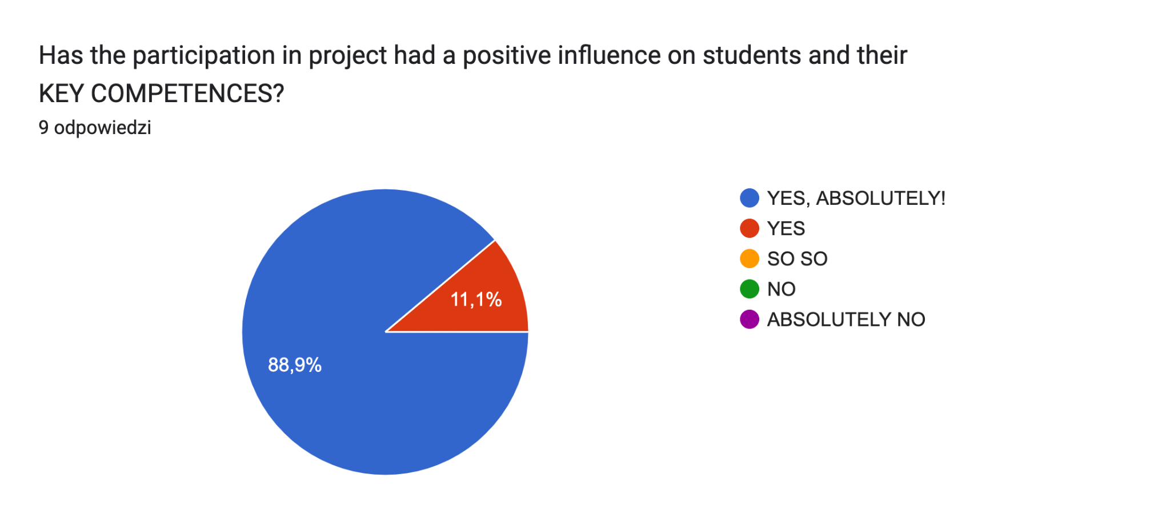

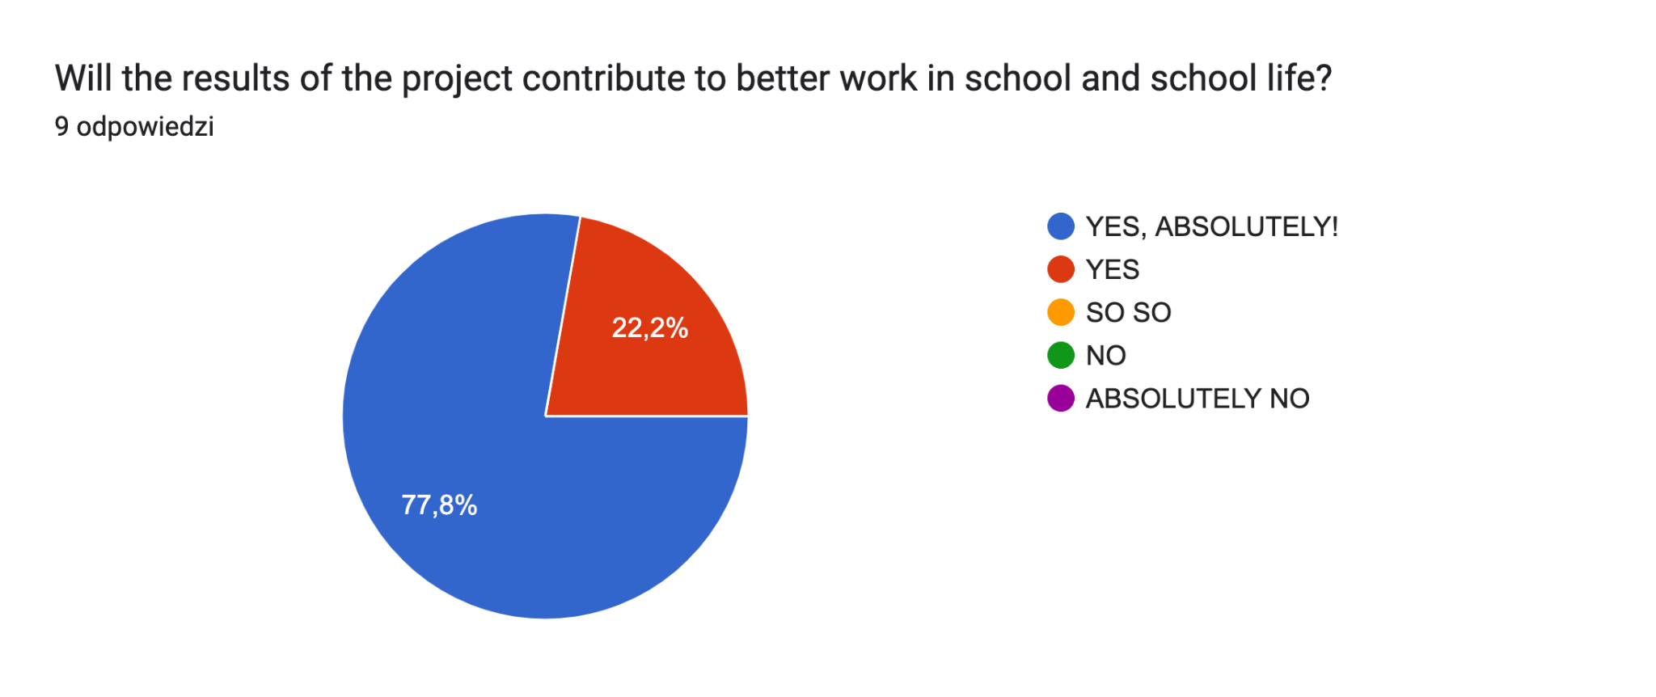
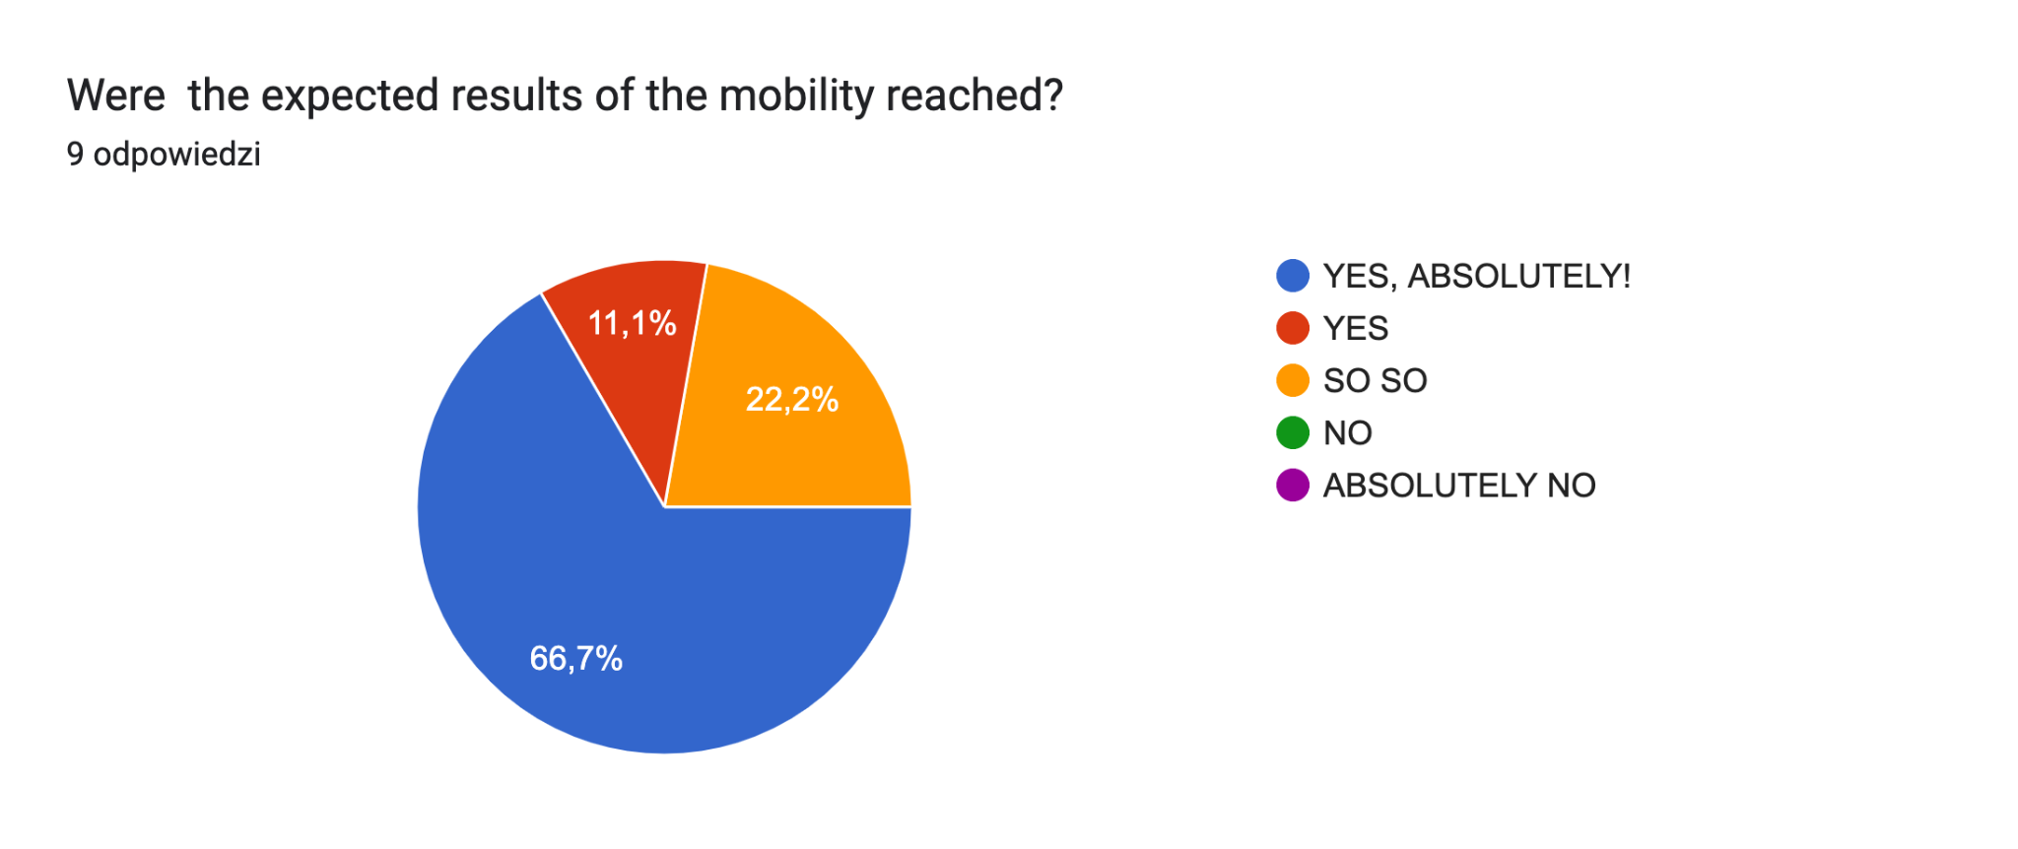

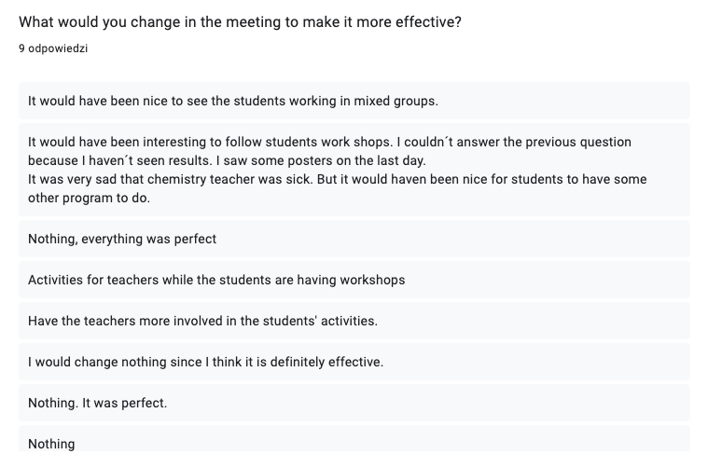
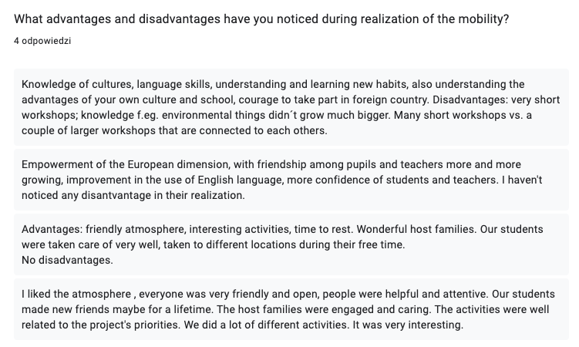

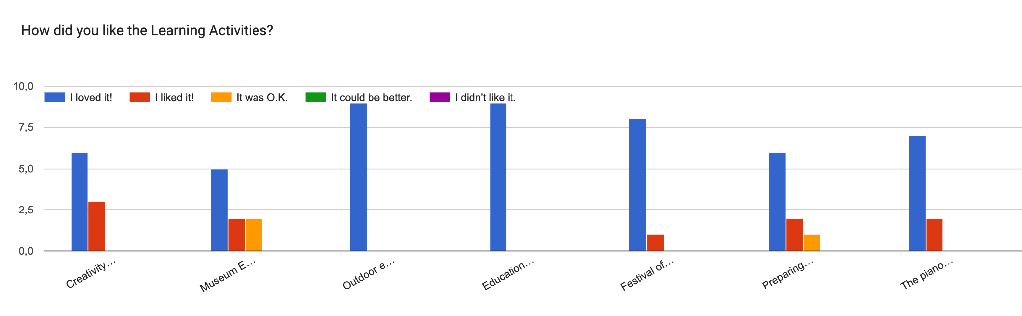
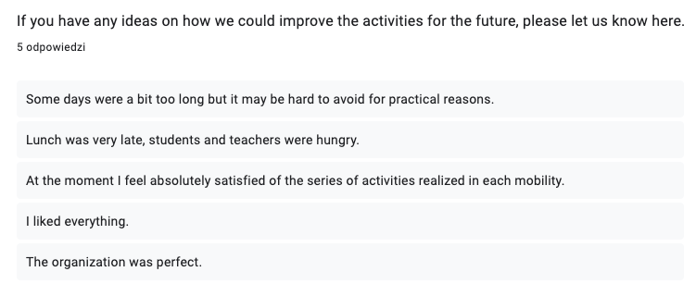
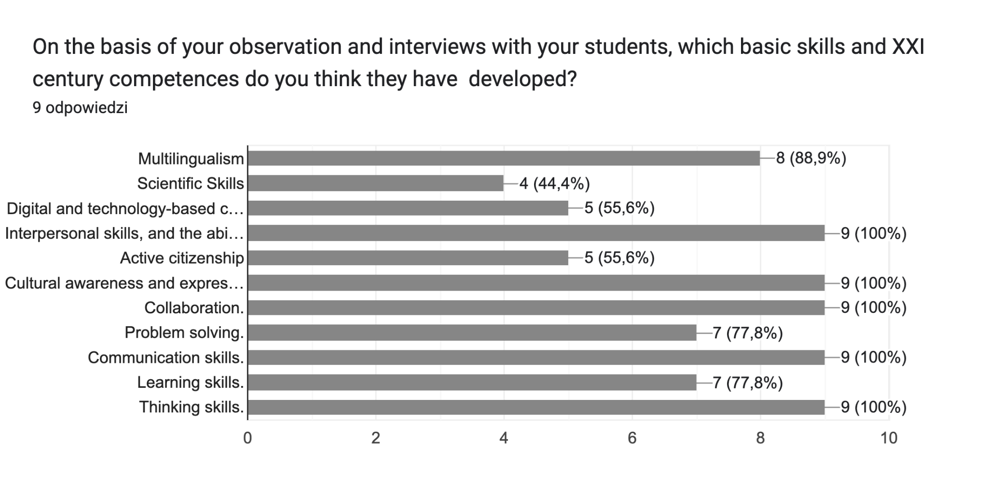

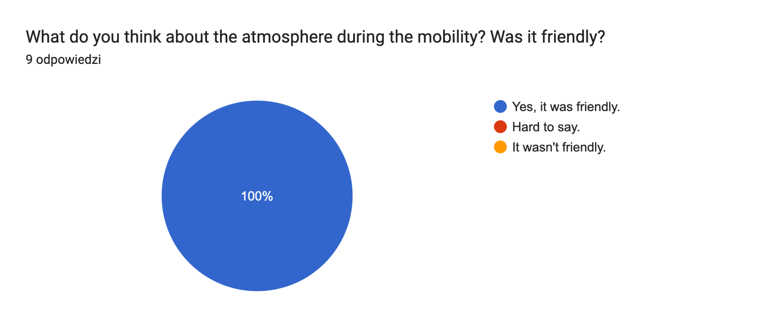
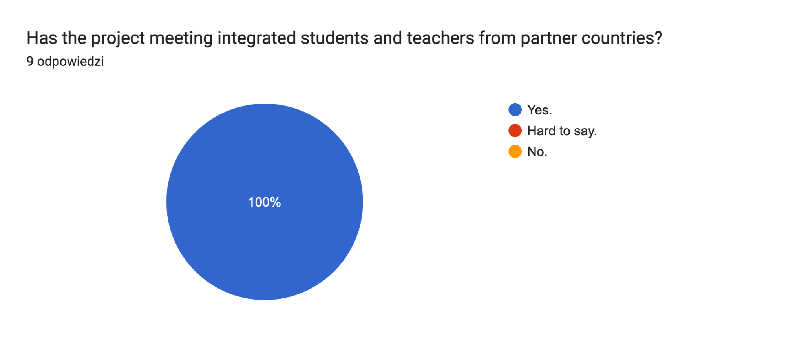
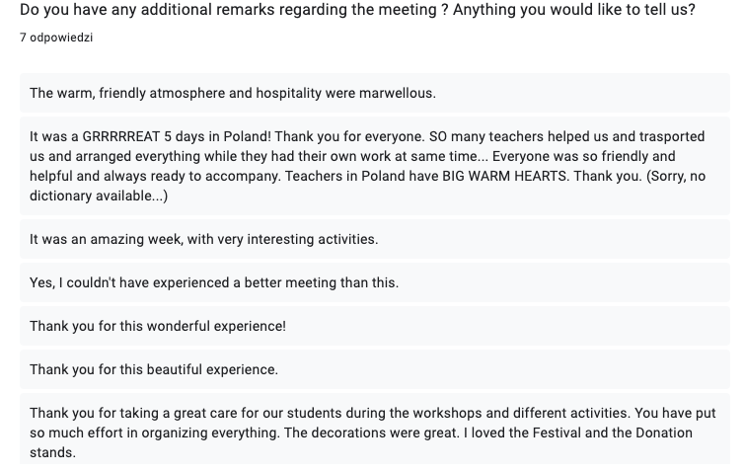

CONCLUSIONS:
We can consider that the goals of the C6 LTTA in Sosnowiec, Poland, have been achieved, because:
- 100% of participating students stated that the topic was interesting to them, which shows that we need to make projects related to the development of soft skills and learning to learn, learning for life competences.
- 100% of participating students now have a few new ideas on how toimprove my self-management skills.
- 100% of the students stated that the activities integrated all the students from all the countries.
- Over 84% of the participants stated they developed the following skills thanks to the LTT activities: Multilingualism, Cultural awareness and expression, Collaboration, Communication skills, Thinking skills, Interpersonal skills, and the ability to adopt new competences. Over 72% of the participants stated they developed their Learning skills.
- The majority of students (95%) learned why being a good self-manageris important and are motivated to become a better self-manager in the future.
- 93% of the students stated the atmosphere was friendly.

AREAS IN NEED OF IMPROVEMENT:

- Most of the students loved the following activities a lot: the concert, Wieliczka Salt Mine and Kraków, Self -management workshops, workshops on coping with stress. Some activities need improvement - we need to rethink the way we will organize the visit to the Silesian Museum in the future to make the participants more interested and engaged. Also take Action workshops need some improvement, as two students didn’t like them.
- In the future we need to engage more science teachers in the project in order to improve scientific skills better. Only 42 % of the participants stated they developed their Scientific Skills. It is caused mainly by the unexpected absence of our chemistry teacher who got ill- we had no replacement for him, as we found out about his absence only one day before the workshops.

A point for discussion:

- Three teachers complained about not having been involved in the workshops for students. One teacher would like to have had special workshops or activities planned for teachers while the students were working. Our explanation - the LTTA in this particular project are planned for students. It is the the students who are the beneficiaries. The teachers participating in the exchanges are involved as accompanying persons for students, not participants, so we were not obliged to include the teachers in the workshops. In fact, there were two reasons we did not include the teachers in the workshops - in some cases we did not have enough space (stress management/ Take action workshops). In other cases (stress-management, integration, self-management workshops), we wanted the students to be on their own without their teachers to feel more comfortable, open and relaxed, and to foster their integration. The presence of teachers observing them (especially teachers they didn’t know) may have disturbed the process. The school psychologist stated that the students were very open while talking about the stressful experiences from their lives during the stress management workshop. She also mentioned it wouldn’t have been possible if the teachers had been present there.
We understand, however, the need of the three teachers to learn and to get inspired by new ideas used in a foreign school. Therefore, we would like to invite all the accompanying teachers to our school for job shadowing. We are always open for you.

The link to the survey for host families:
https://docs.google.com/forms/d/e/1FAIpQLSdy5RbnL7-bezYAVo6hKnScbDB2FFMpLTl9joVMM_ywf3ZeAg/viewform?usp=sf_link
We received 15 answers.

HOST FAMILIES’ ANSWERS (IN POLISH)
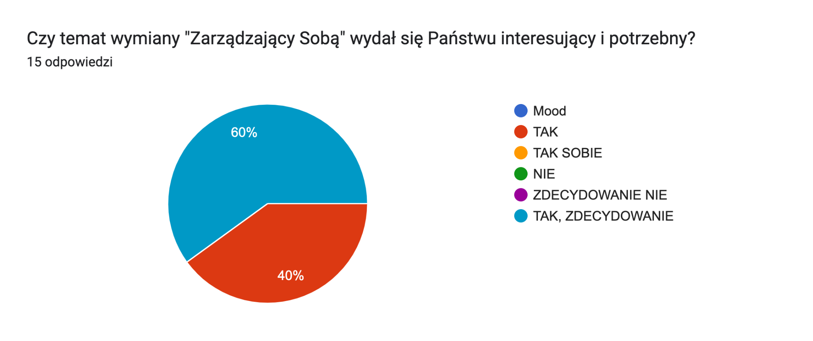
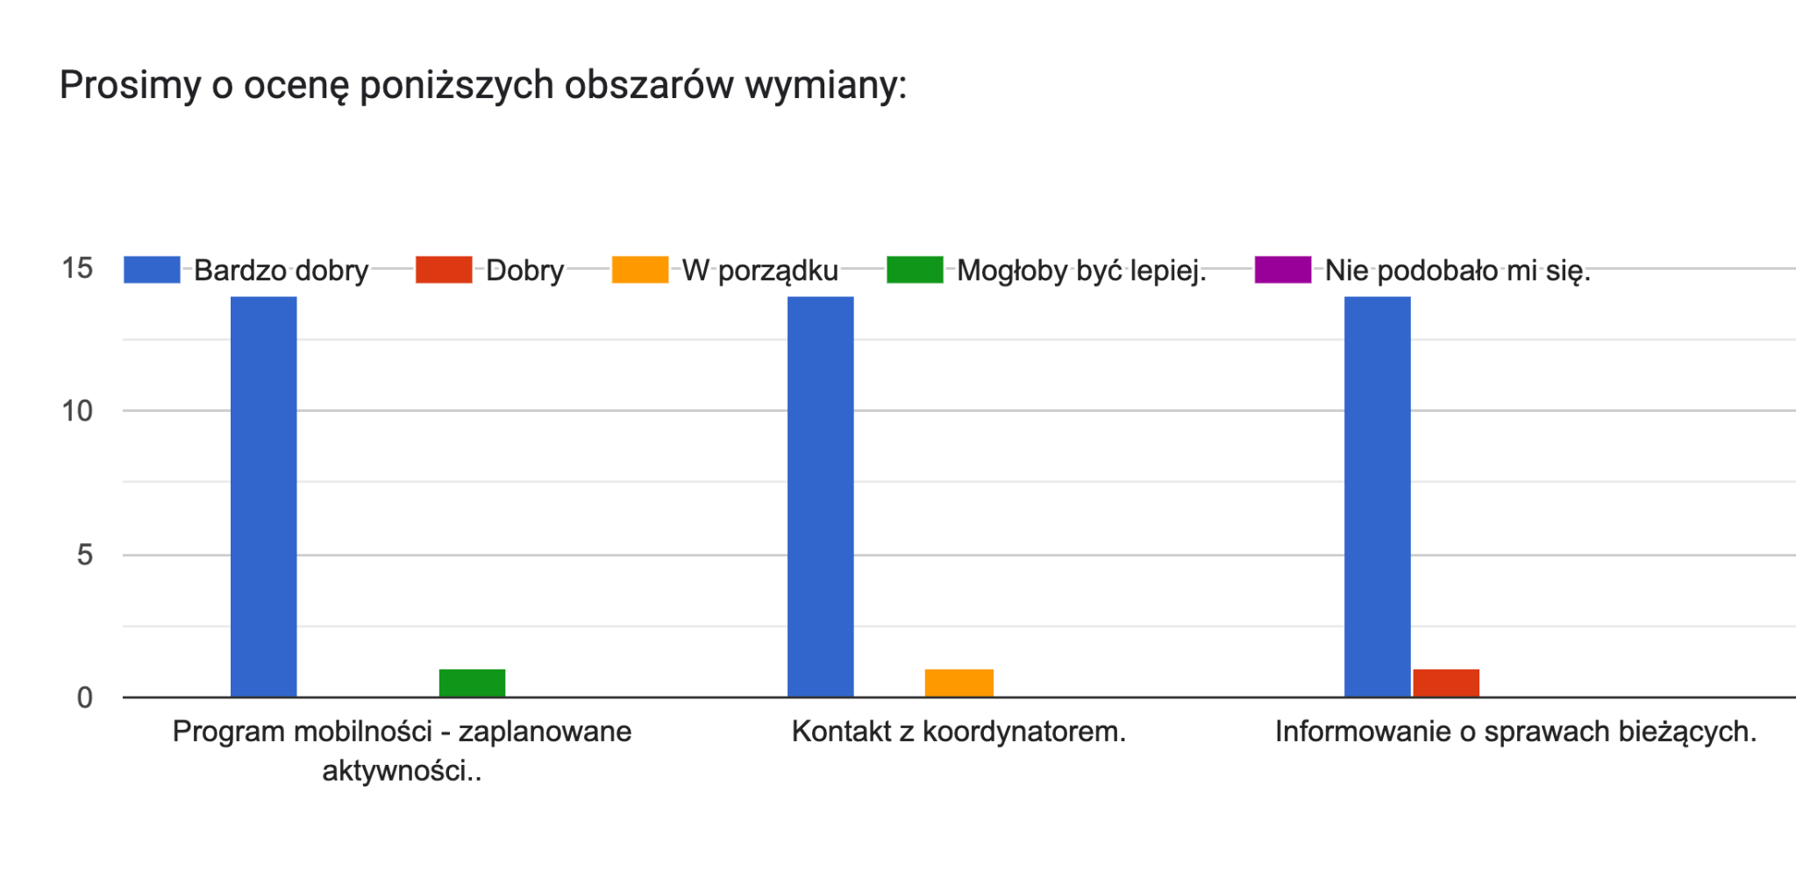
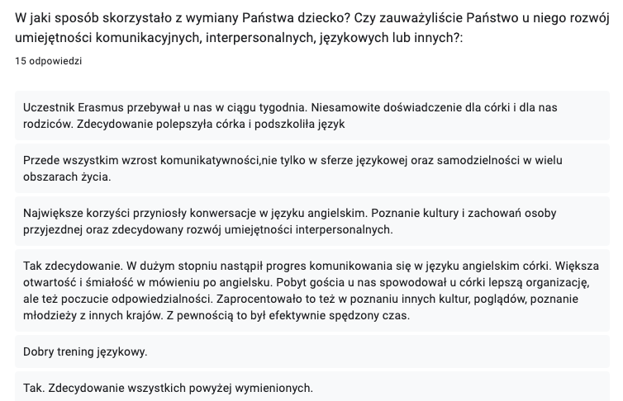

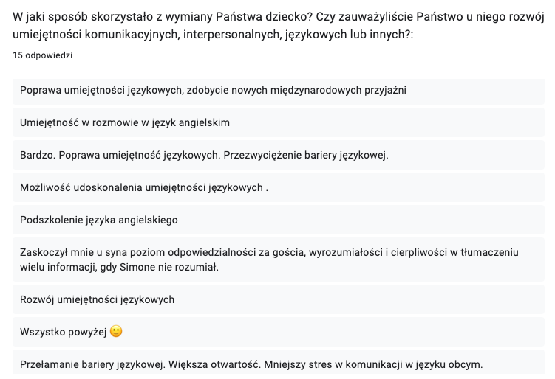
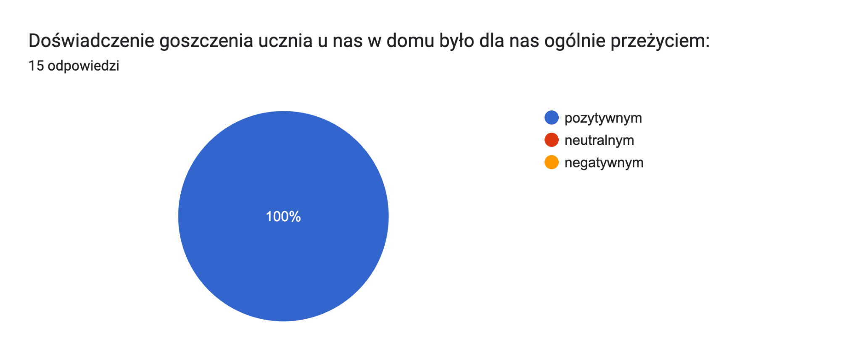
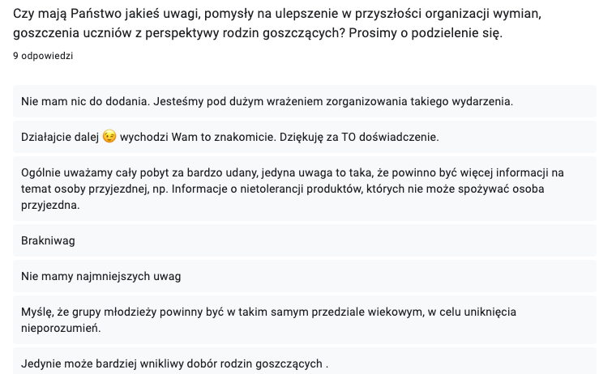
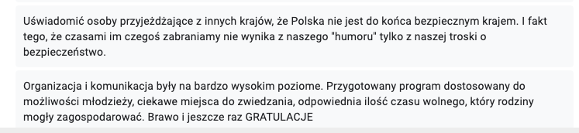

CONCLUSIONS:
- 100% of the host families consider the experience as positive
- 100% of the host families consider the topic of the exchange “Self-Managers” useful, important, and practical
- 93% of the host families loved the programme of the exchange (the planned workshops and activities)
- The majority of the host families mention they have noticed the development of the following skills in their children: communication skills, linguistic skills (English and other partner languages), responsibility and the level of care for the guest, breaking speaking barriers, self-confidence.
- The majority of the host families appreciate the new international friendships they gained thanks to the project. Even the Polish students form the Polish school integrated with one another and made friends among themselves (theyr were from different classes and had not known each other before the exchange).

AREAS FOR IMPROVEMENT:
- One family asked for a better process of matching the students with the families - in the future we will ask the partners to provide us with a small personal profile of the coming students
- One family asked us to explain the teenage guests in the future that the host families are responsible for their guests safety and therefore they sometimes need to make hard decisions, which are sometimes hard to accept for the students. It is not bad will. It is care.

The evaluation prepared by the project coordinator, Mrs Katarzyna Baca, Sosnowiec, 21.12. 2022.

